The US Cardiovascular Diseases Lifestyle Risk Prediction Research

**1. Situation understanding**

**1.1 Identify the objectives of the situation**

a. background information

Cardiovascular Disease (CVD) refers to a group of diseases that affect the functioning of the heart and blood vessels, including coronary heart disease, heart attacks, strokes, high blood pressure, and heart failure. For many years, CVD has been a significant global public health concern, significantly impacting overall health and well-being.

Statistics indicate that CVD is the leading cause of death in the United States, resulting in 874,613 deaths in the United States in 2019(Connie W. Tsao et al., 2022). Despite advancements in medical technology and healthcare services that have helped reduce CVD-related mortality rates, its incidence continues to rise (Connie W. Tsao et al., 2022). This disease poses significant challenges to public health, exerting a profound impact on health, economics, and society.

Preventing CVD has become an urgent task, and early or preemptive interventions are crucial measures in reducing the risk of CVD. Among the modifiable risk factors contributing to the pathogenesis of CVD, lifestyle factors play a prominent role. In recent years, urbanization and modernization have led to significant changes in people's lifestyles, fostering unhealthy habits that contribute to the high prevalence of cardiovascular diseases.

Therefore, understanding the relationship between lifestyle and cardiovascular diseases and exploring how improving lifestyle can prevent and manage CVD have become critical topics in the field of public health.

b. objectives and success criteria

This research aims to investigate the association between cardiovascular diseases and lifestyle, seeking key connections between lifestyle choices and cardiovascular health through the collection and analysis of large sample data. It is hoped that this study will provide scientific evidence for the development of targeted public health interventions and personalized health recommendations, aiming to reduce the incidence and mortality rates of cardiovascular diseases and enhance people's quality of life and overall health.

* The objectives of the CVD Lifestyle Risk Prediction Research are:

1. To assess the impact of different lifestyle choices on the likelihood of developing CVD.

2. To predict the risk of CVD based on lifestyle factors.

* The success criteria of the CVD Lifestyle Risk Prediction Research are:

1. To provide actionable insights and recommendations for individuals to mitigate their CVD risk through lifestyle modifications.

2. To contribute valuable information for public health initiatives aimed at reducing the burden of CVD through targeted interventions and awareness campaigns.

3. To enhance the understanding of the relationship between lifestyle choices and CVD risk, enabling informed decision-making by healthcare professionals and policymakers.

**1.2 Assess the situation**

1.2.1 resource inventory

a. Hardware Resources:

Computer: High-performance computer or server capable of handling large-scale data analysis and model training.

Storage Devices: Sufficiently large hard drive space to store and manage a vast amount of data.

Database Server: Used to store and manage data in the database.

b. Data Sources:

Centers for Disease Control and Prevention (CDC): The CDC provides rich cardiovascular disease statistics and epidemiological information.

Medical Databases: Such as the National Health and Nutrition Examination Survey (NHANES), Medical Expenditure Panel Survey (MEPS), American Heart Association (AHA), etc.

Population Statistics Data: Demographic information, such as data from the U.S. Census.

Socioeconomic Data: For instance, employment and income data from the U.S. Bureau of Labor Statistics (BLS).

c. Knowledge Storage:

Literature Databases: Academic literature databases (e.g., PubMed, Google Scholar) can be used to search for relevant published research papers.

Data Storage and Backup: Ensuring data is securely stored and backed up to prevent loss of critical data.

d. Human Resources:

Data Scientists/Analysts: Responsible for data cleaning, analysis, and modeling.

Programmers: Responsible for developing and maintaining data analysis code and tools.

Subject Matter Experts: Familiar with cardiovascular diseases and lifestyle to provide insights and guidance on research direction.

Data Administrators: Responsible for data management and maintenance.

Project Managers: Coordinate team members, manage project progress, and allocate resources.

But currently, all the work is done by me. I will take all the job in this project.

1.2.2 Requirements, Assumptions, and Constraints

a. Requirements:

I need to ensure legal access and use of data, comply with data privacy and protection laws, and avoid disclosing sensitive information. The research results will be submitted to the University of Auckland through the Canvas student management system in the form of an assignment. The submission will include the report itself, raw data, and the data manipulation process used in the project.

b. Assumptions:

During the data collection process, I need to use free and open data sources to avoid incurring any costs. Regarding the data found, I will assume that its quality is reliable and accurate and it can be used to support my research objectives. As the project manager, my goal is to obtain the final conclusions through a robust model. If the model itself is flawed, I won't be able to arrive at the correct conclusions. To achieve accurate and meaningful results, a sound model is essential, but ultimately, the final conclusions are what matter the most.

c. Constraints

I need to ensure that I have access to the necessary data by having the required login credentials, such as using my student account credentials to access academic papers in the school library. For the data itself, I may also need to set up an opening password. However, at present, the data I have does not contain any personally sensitive information, so I do not need to set up a password for it. Additionally, the data I have is free and publicly available, and I will only be submitting it through the school's assignment submission system without uploading it to any other websites or platforms. Therefore, I will comply with all legal, ethical, and privacy constraints related to data usage and research.

1.2.3 Risks and Contingencies

a. Plan Risk:

Risk Description: The project may take longer than expected, leading to delays in progress.

Contingency Plan: Conduct a thorough evaluation of the project's complexity and time planning, regularly check the progress, and if necessary, adjust the research methods or scope to ensure the project is completed on time.

b. Data Risk:

Risk Description: Poor data quality or narrow scope may affect the credibility and effectiveness of research results.

Contingency Plan: Perform comprehensive data quality assessment and preprocessing before data collection, consider the reliability of data sources, increase the diversity of data sources, or reevaluate the research questions to adapt to the available data.

c. Result Risk:

Risk Description: The initial results may not meet expectations, potentially hindering the achievement of research objectives.

Contingency Plan: Promptly review and analyze the results, try different data analysis methods or models, seek advice from mentors or domain experts, reevaluate the research questions, and ensure meaningful results are obtained.

* 1. **Determine data mining objectives**

1. Data Mining Problem Type: Predictive Problem

Objective: To predict whether or not the given person may have cardiovascular diseases based on different lifestyle choices.

1. Technical Goal:

To find which lifestyle or lifestyle combination may be associated with the development of cardiovascular diseases.

1. Specific Numerical Goal:

To provide a relatively accurate risk assessment for the individual's likelihood of developing cardiovascular diseases, for example, predicting the probability of the individual developing cardiovascular diseases if the person continues his/her lifestyle.

**1.4 project plan**

|  |  |  |  |
| --- | --- | --- | --- |
| Table 1: Iteration 1 Project Plan | | | |
| **Phase** | **Time** | **Job** | **Risks** |
| Business Understanding | 7.17-7.20 | Topic choosing | Hard to decide which topic to choose from. |
| Data Understanding | 7.21-7.27 | Search data | Hard to find free open data, or the data is irrelevant to research. |
| Data preparation | 7.28-8.1 | Clean data, preproduce data | Data is not enough after clean, or some of the data is not included. |
| Data transformation | 8.2 | reduction and projection | The use of software is not skilled and takes a long time |
| Data-mining method(s) selection | 8.3-8.6 | Method selection from IPSS current ones | It does not match the objective and needs to redo. Take longer time than expected. |
| Data-mining algorithm(s) selection | 8.7-8.10 | algorithm selection from IPSS's current ones | It does not match the objective and needs to redo. Take longer time than expected. |
| Data Mining | 8.11-8.12 | Search for pattern | Hard to find a pattern |
| Interpretation | 8.13-8.15 | Visualize, interpret, evaluate, and iterate | Take longer than expected |
| Report Evaluation | 8.16-8.17 | Report writing and evaluation | Report Template |

**2. Data understanding**

**2.1 Collect initial data**

The initial data for my research was obtained from the Kaggle.com website. Initially, I tried to obtain the data from the official website of the Centers for Disease Control and Prevention (CDC) Behavioral Risk Factor Surveillance System (BRFSS). However, I found that the data format provided on the website was not compatible with the SPSS software. As a result, I searched for alternative sources through other channels.

Eventually, I discovered the same data source onKaggle.com, but it had undergone some relevant preprocessing related to my research topic. The website is <https://www.kaggle.com/datasets/alphiree/cardiovascular-diseases-risk-prediction-dataset>.

Additionally, this data was available in CSV format, which can be used with SPSS and is compatible with most data analysis software, making the subsequent data analysis process simpler. Consequently, I downloaded this preprocessed data from Kaggle.com to my local computer, facilitating my further analysis and operations.

**2.2 Describe the data**

The Behavioral Risk Factor Surveillance System (BRFSS) is the nation’s premier system of health-related telephone surveys that collect state data about U.S. residents regarding their health-related risk behaviors, chronic health conditions, and use of preventive services.

The dataset I got is based on the BRFSS Dataset in 2021. The dataset is in CSV format and size is 30.9 MB. There are 19 columns and 308854 rows. These 19 columns represent the content of lifestyle-related factors. They are General Health, Checkup, Exercise, Heart Disease, Skin Cancer, Other Cancer, Depression, Diabetes, Arthritis, Sex, Age Category, Height(cm), Weight(kg), BMI, Smoking History, Alcohol Consumption, Fruit Consumption, Green Vegetables Consumption, and Fried Potato Consumption.

The dataset is in tabular format, comprising 7 columns of continuous data, 9 columns of flag data, 2 column of nominal data, and 1 columns of ordinal data.

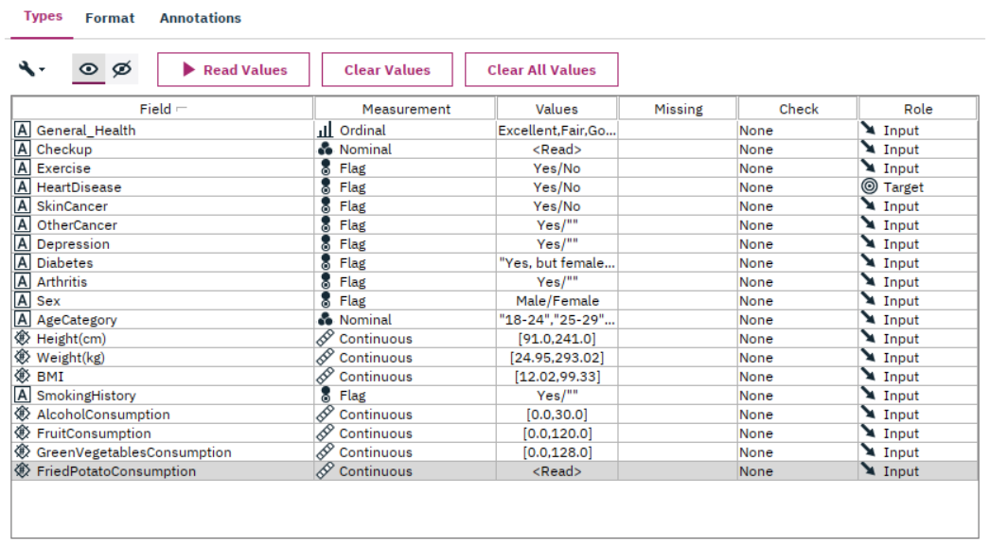

*Figure 1: Type of the data*

As the screenshot shows, 7 columns of continuous data are Height, Weight, BMI, Alcohol Consumption, Fruit Consumption, Green Vegetables Consumption, and Fried Potato Consumption. 9 columns of flag data are Exercise, Heart Disease, Skin Cancer, Other Cancer, Depression, Diabetes, Arthritis, Sex, and Smoking History. 2 columns of nominal data are Age Category and Checkup. 1 column of ordinal data is General Health.

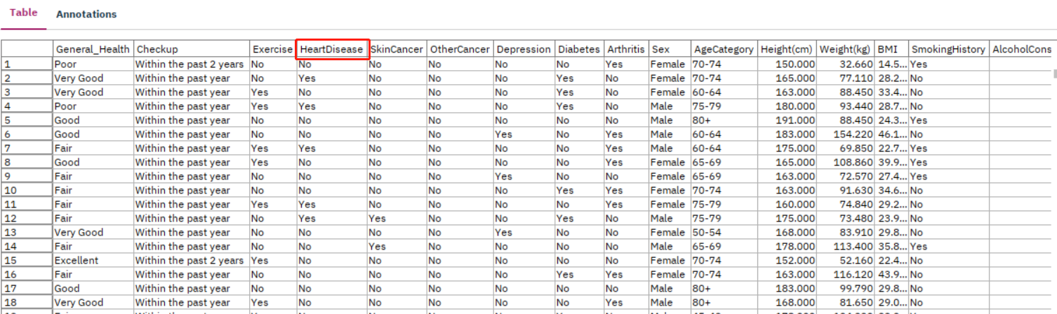

*Figure 2: Dataset table screenshot part 1*

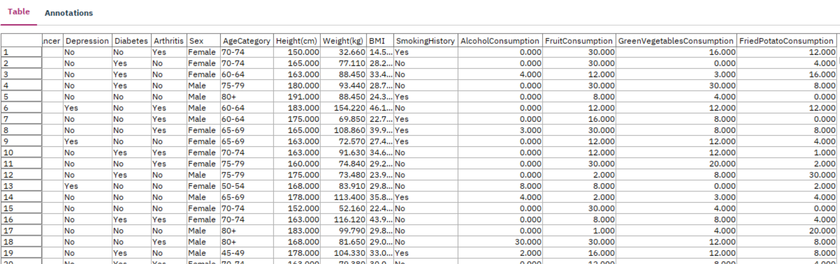

*Figure 3: Dataset table screenshot part 2*

The above screenshot is of my data table, displaying what each column in the table represents and the numbers shown in each row across the various columns. The column I have outlined in red is my target, indicating whether or not the person has heart disease.

**2.3 Explore the data**

My data sample is quite large, but through the visualizations provided below, I can make initial explorations of the data's content and patterns.

Currently, my hypothesis is that the main factors influencing the occurrence of cardiovascular diseases are:

1. Gender

2. Age

3. BMI (Body Mass Index)

4. Alcohol consumption.

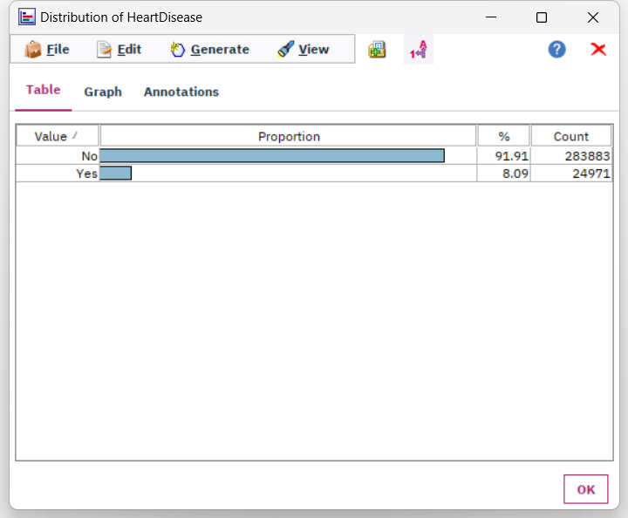

*Figure 4: Distribution of Heart Disease*

The above table describes the target field of my data, the proportion of patients with heart disease. In my data, 91.91%, or 283,883 people, do not have heart disease, while 8.09%, or 24,971 people, have heart disease. I need to identify common characteristics among these individuals with heart disease by examining other columns. I'll be looking to find meaningful differences in lifestyle compared to those without heart disease to draw relevant conclusions.

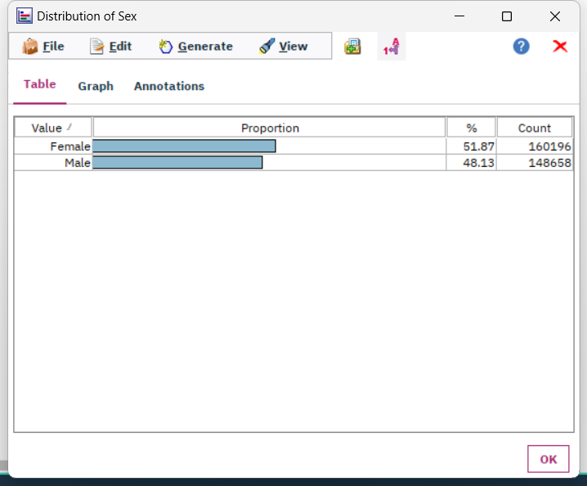 *Figure 5: Distribution of gender*

The above chart represents the gender distribution in my overall data. 51.87%, or 160,196 people, are female, while 48.13%, or 148,658 person, are male.

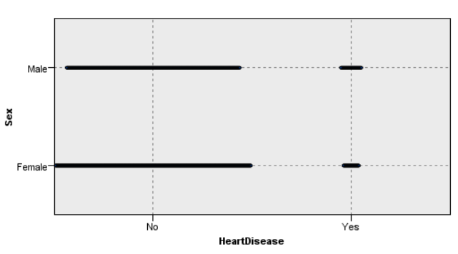

*Figure 6: Graphboard of heart disease and gender*

The above figure is a 2D dot plot relating to the presence or absence of heart disease and gender. It displays the gender comparison between individuals who have heart disease and those who do not.

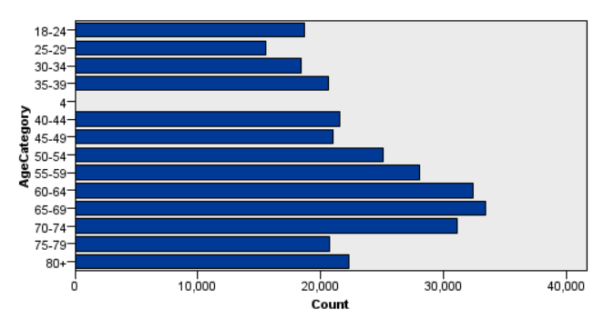

*Figure 7: Distribution of age categories*

The above bar chart displays the distribution of age categories in the data, and we can also see some invalid data. These dirty data will be cleaned or optimized in the subsequent stages.

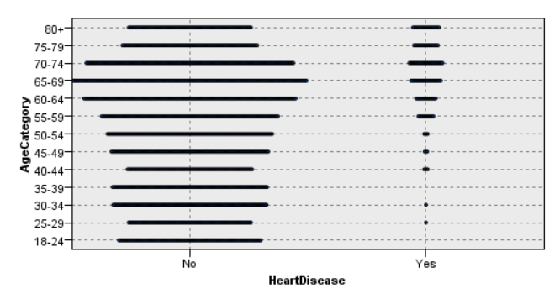

*Figure 8: Graph board of heart disease and age*

The above figure is a 2D dot plot relating to the presence or absence of heart disease and age categories. It displays the age categories comparison between individuals who have heart disease and those who do not.

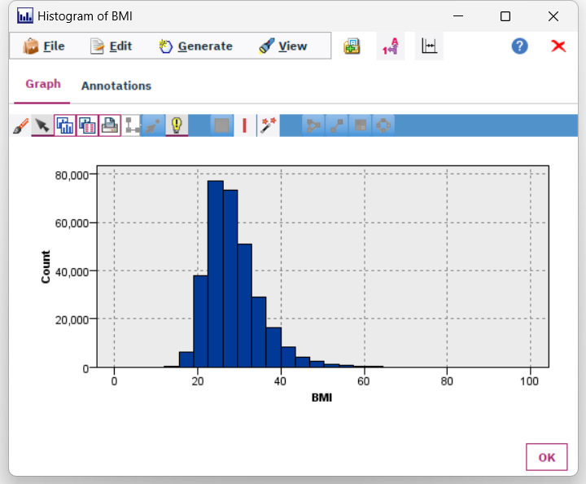

*Figure 9: Histogram of BMI*

The above histogram displays the distribution of BMI in the data, which is a skewed distribution. The vast majority of people have a BMI value ranging from 20 to 40.

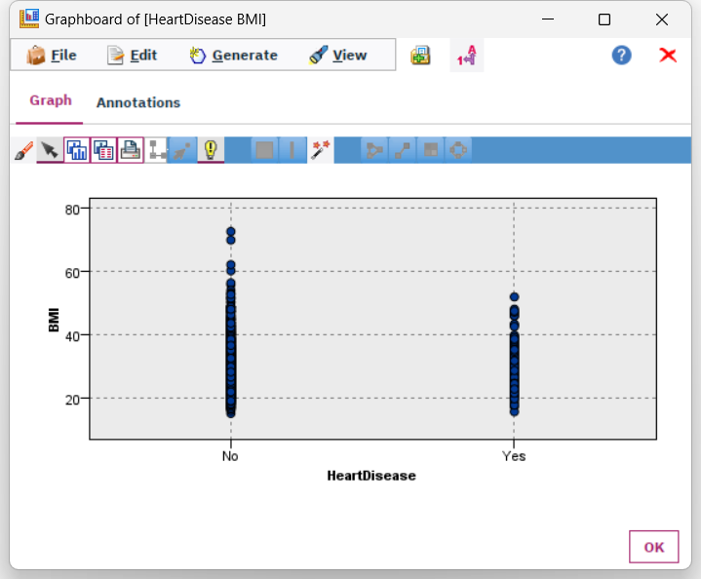

*Figure 10: Graph board of heart disease and BMI*

The above figure is a 2D dot plot relating to the presence or absence of heart disease and BMI numbers.

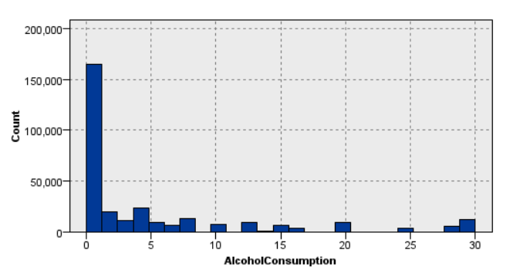

*Figure 11: Histogram of Alcohol Consumption*

The above histogram displays the distribution of Alcohol Consumption in the data. The majority of people's alcohol consumption is between 0 and 1.

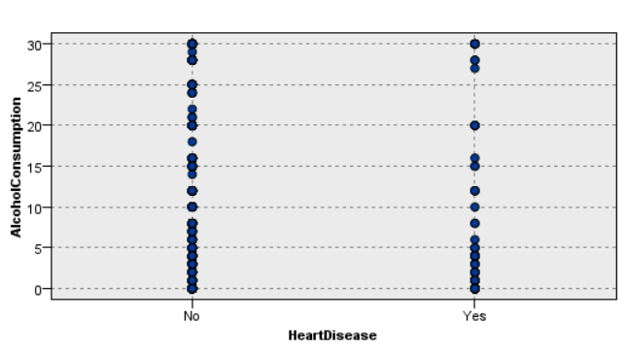

*Figure 12: Graph board of heart disease and alcohol consumption*

The above figure is a 2D dot plot showing the relationship between the presence or absence of heart disease and alcohol consumption. From the chart, we can see that when alcohol consumption falls within the range of 21-26, there are no instances of heart disease.

**2.4 Verify the data quality**

In the diagram shown below, the majority of the data in my database is complete, but there are still some issues with errors and missing values.

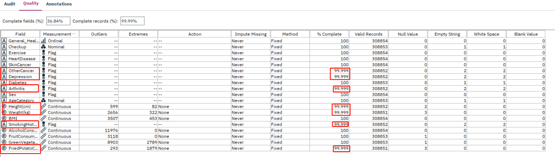

*Figure 13: Data audit of 19 fields*

In the diagram above, I've circled in red the part where the data is absent or invalid.

Among all the fields, Other Cancer, Depression, Arthritis, Height(cm), Weight(kg), Smoking History, Fried Potato Consumption, have fewer complete percentage. Alcohol consumption has the most outliers which is 11976. The Green Vegetables Consumption and Fried Potato Consumption have the most extremes which are 2789 and 1879. The fields with null values are Height, Weight, Fruit Consumption, Green Vegetables Consumption, and Fried Potato Consumption. Empty string and white space affect Check Up, Other Cancer, Depression, Diabetes, Arthritis, Age Category, and Smoking History.

I will proceed to clean and enhance the data in the following steps.

**3. Data Preparation**

**3.1 Select the data**

Now, I have gained a relatively superficial understanding of my data. Next, I need to build on this by selecting from the existing raw data. I will make the selection based on the following factors.

1. Select data by business objectives

My business objectives are “to assess the impact of different lifestyle choices on the likelihood of developing CVD” and “to predict the risk of CVD based on lifestyle factors”.

In the raw data, some columns' content is irrelevant to lifestyle or cannot provide effective predictions and suggestions. The "Checkup" column records(figure.14 below) the last time a physical examination was conducted, reflecting whether the subject undergoes regular checkups and the frequency of those checkups.

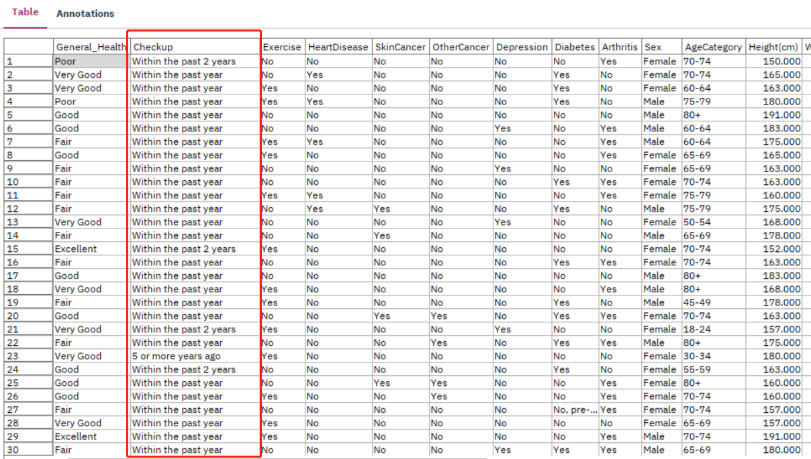

*Figure 14: The checkup column values in the dataset*

This factor does not align with the causes of heart disease. Patients can diagnose certain illnesses through physical examinations, but the act of having regular checkups itself has no direct correlation with acquiring diseases.

Furthermore, we often see that people who have regular physical examinations are more likely to be diagnosed with illnesses. It's not that those who don't have regular checkups are less prone to illness, but rather they find it difficult to diagnose diseases because they don't get checked. In other words, those who do not have regular checkups often remain unaware if they contract certain illnesses, and only when severe complications appear or the disease progresses to an unignorable stage do they seek medical attention and receive a diagnosis. Therefore, the data in this field need to be excluded

1. Select data by data quality
2. Null value

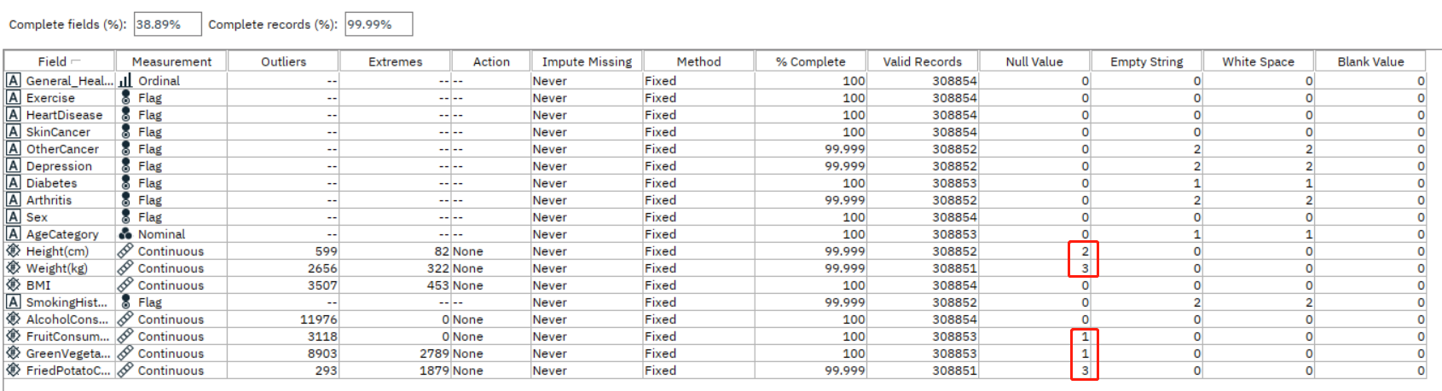

*Figure 15: The audit of the dataset circled null value*

The above indicates that in the audit of the dataset, some columns have null data values, and I need to impute the missing values for these null entries.

1. Unclassified value

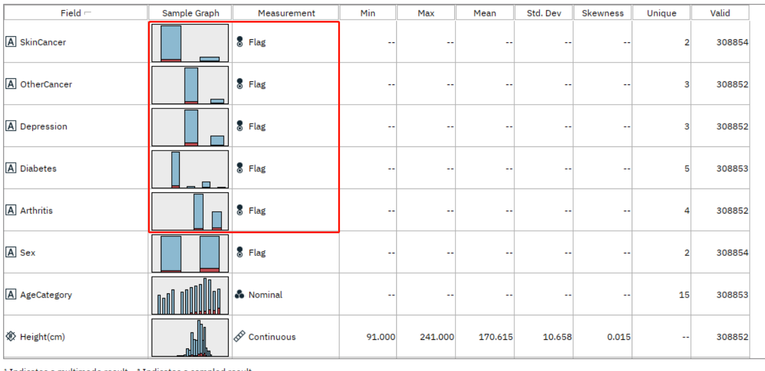

*Figure 16: Data audit of dataset*

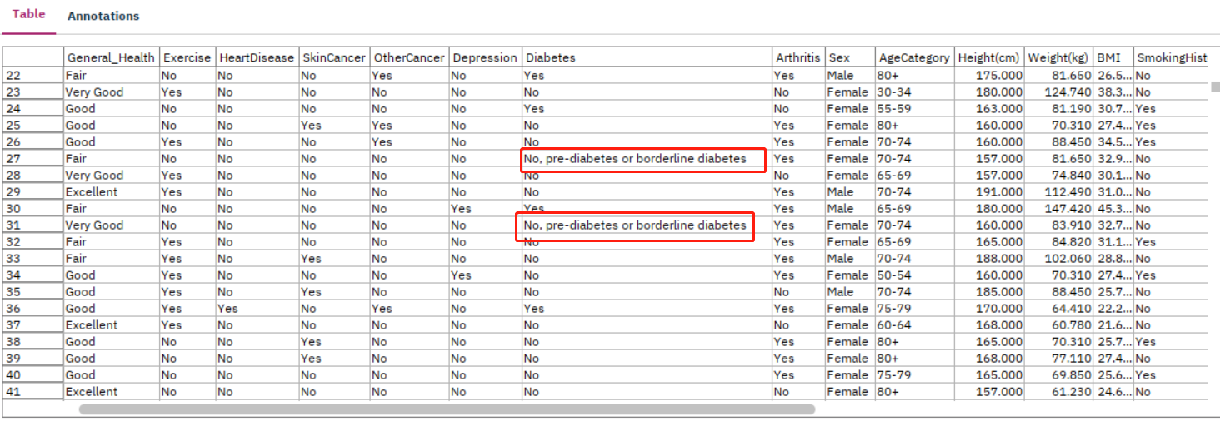

*Figure 17: Invalid Data in flag data field*

Figure 16 displays the basic information of the dataset. The data in the red box are of flag type, indicating whether or not a particular disease was contracted. Only this result is needed, without requiring specific details. However, their sample graph is not limited to just two bars, and the data rows that do not belong to "yes" and "no" categories need to be modified to "yes" or "no." As seen in Figure 17, the content in the two cells circled in red should be changed to "no."

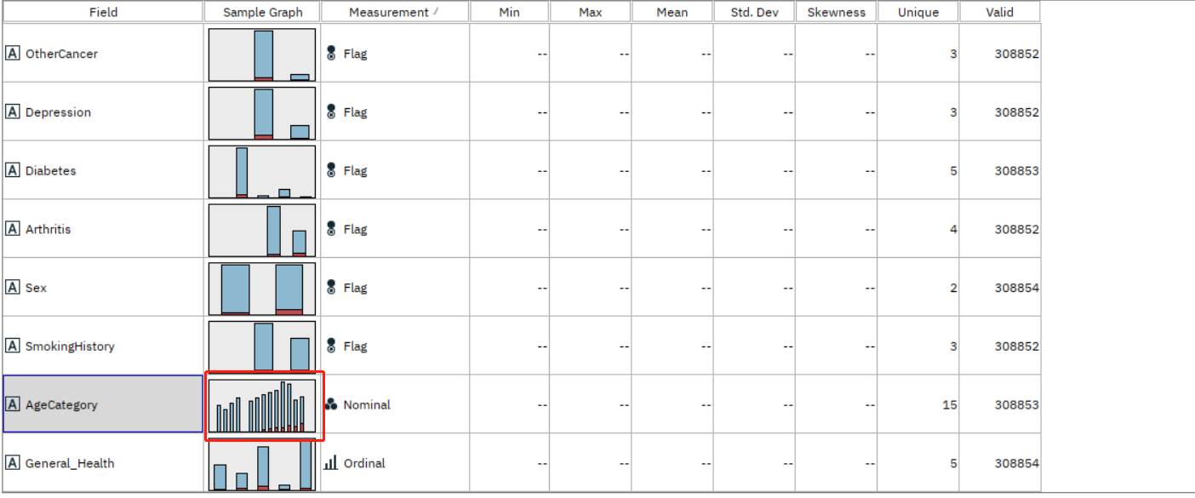

*Figure 18: Data audit of filtered data part 2*

In the data audit shown in the above figure, I have circled in red a gap that appears amidst a bunch of bars. This gap is caused by a category that contains only a very small number of values. This category does not align with the "age category" field. The data rows corresponding to this category need to be reclassified.

1. Empty value

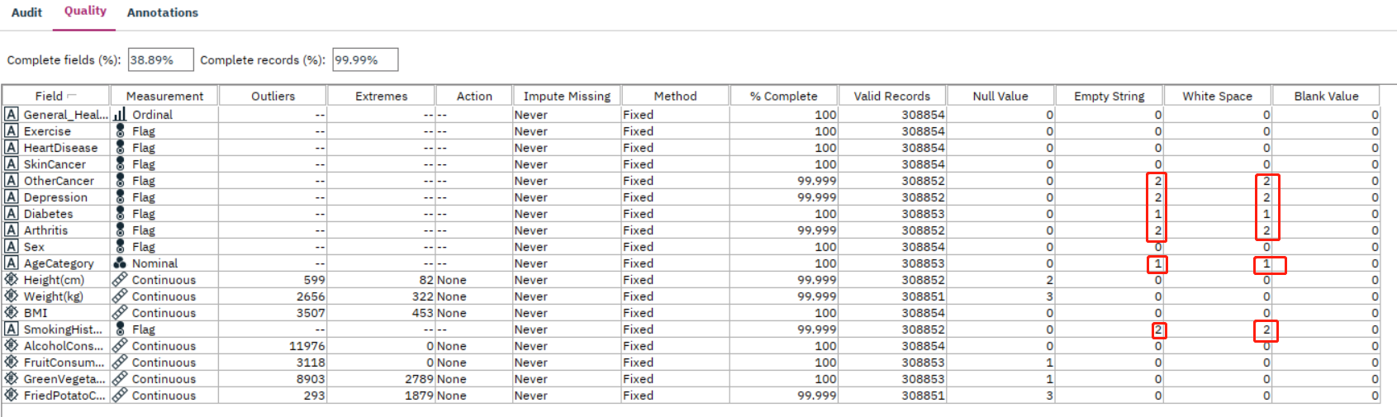

*Figure 19: The audit of the dataset circled empty values*

In addition to null values, there are also some empty values in the table. These data also need to be imputed.

1. Outliers and extremes

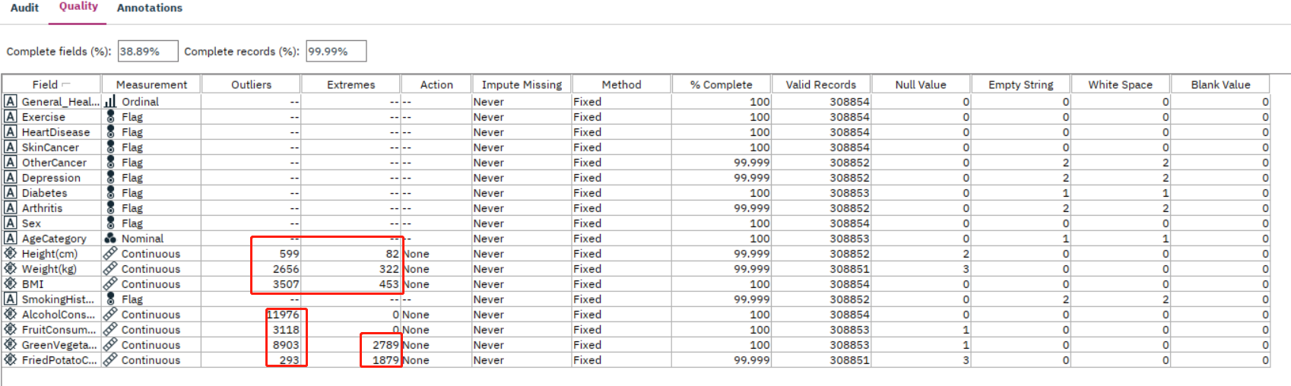

*Figure 20: The audit of the dataset circled outliers and extremes*

The data audit in the above figure shows some outliers and extremes, which are the red-circled ones. Some of these values also need to be addressed.

**3.2 Clean the data**

As I mentioned in Section 3.1 "Select the data," I need to remove the columns that are unrelated to my business objectives.

Additionally, I need to modify or remove any invalid data.

1. unrelated columns

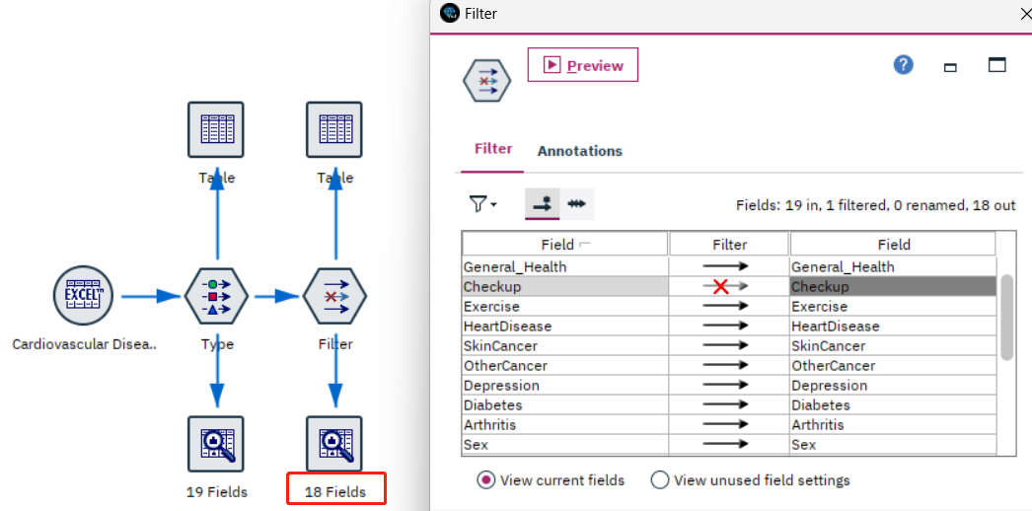

*Figure 21: Filter out the field that is irrelevant to business objectives*

The graph displayed above illustrates the node I employ to exclude the "Checkup" field, which needs to be removed as they are unrelated to the business objectives. By selecting the "Checkup" field in the filter node, I can eliminate the data within this field. The red circle highlights the audit node, which shows a change from 19 to 18 fields. This reduction confirms that the elimination was successful.

1. Null value data

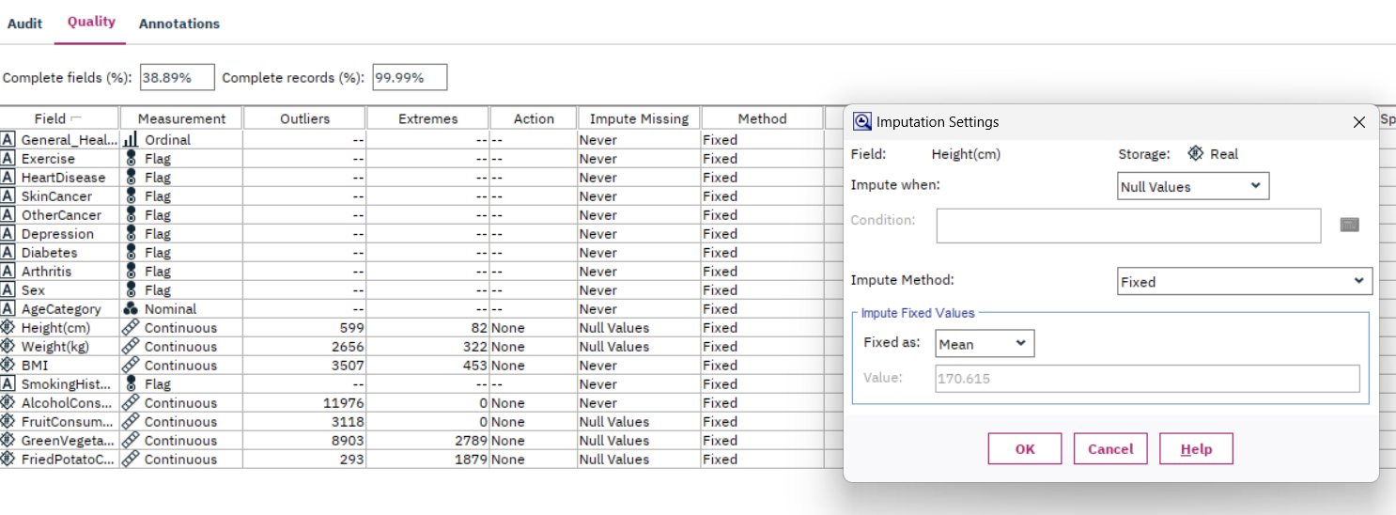

*Figure 22: impute missing value method selection for null values*

As shown in the graph above, I select "impute missing" for null value, and in the method section, I choose to fill these null values with the mean. These methods are the most common method choice for null values. The methods can also be used for the current situation in my dataset.

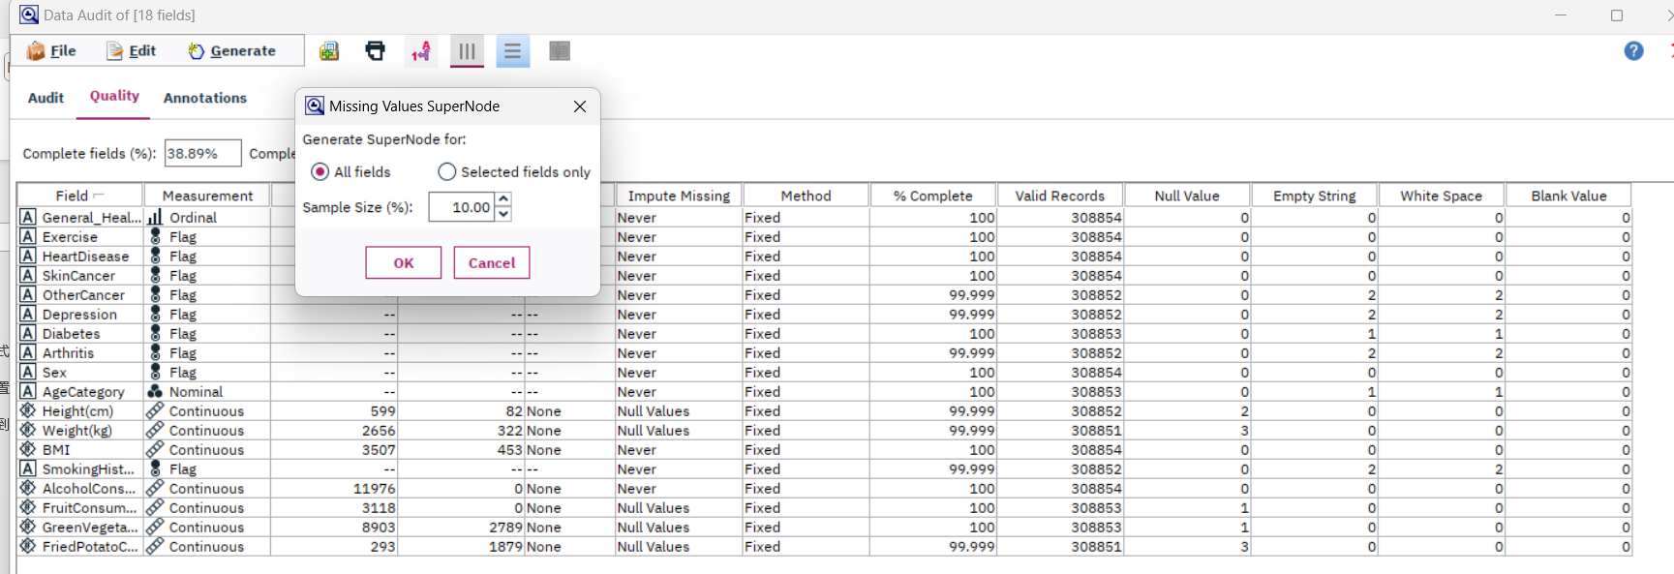

*Figure 23: Missing value SuperNode choice*

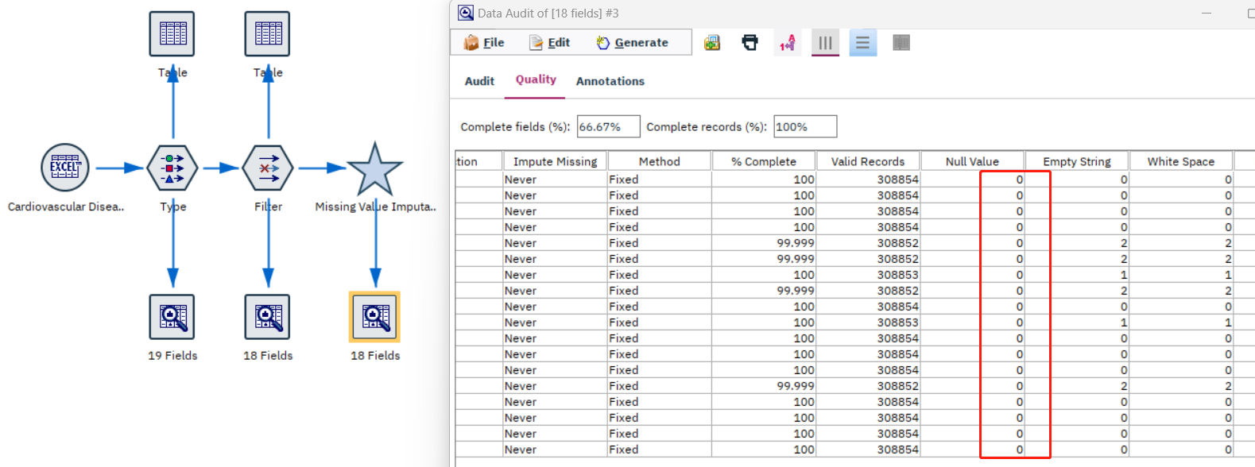

*Figure 24: Audit information after missing value impute*

As the graph shows above, the null value has been all refilled with values, and no null values remain. The zeros in the red circle shows that there is no null value.

1. Unclassified value

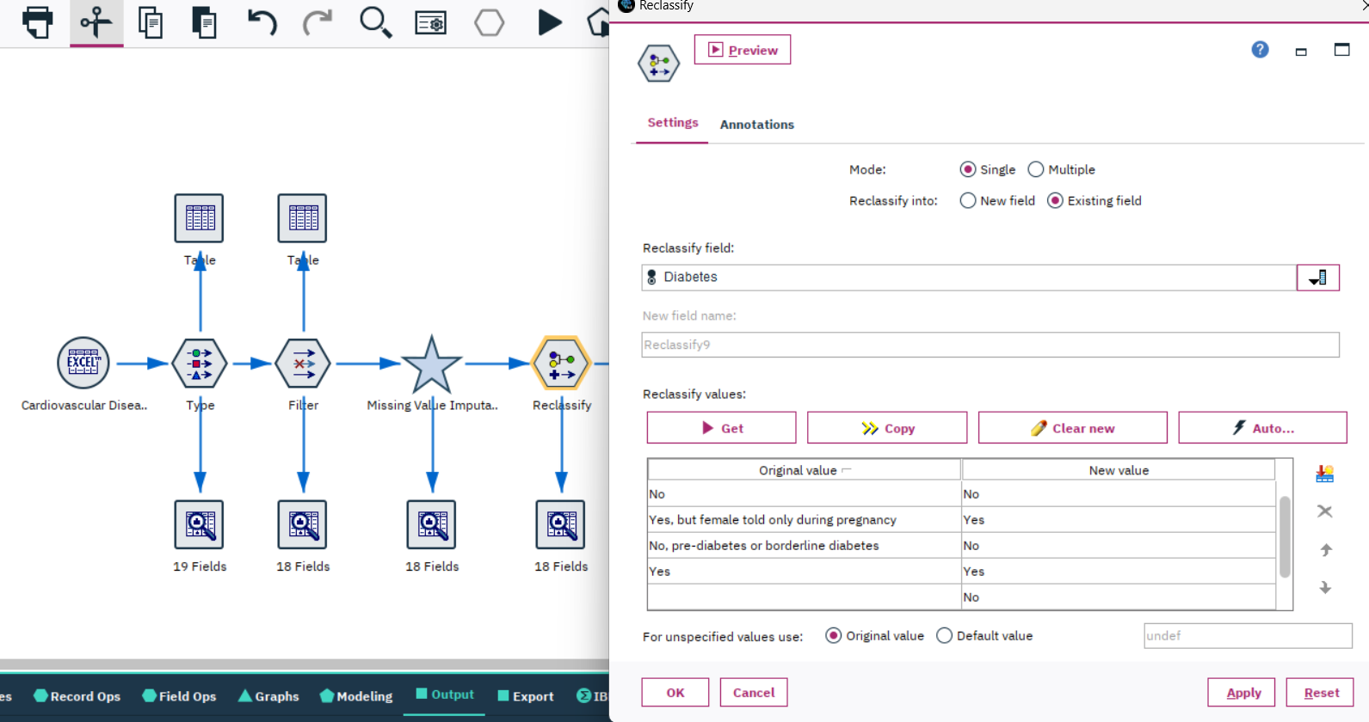

*Figure 25: Classify Diabetes Column*

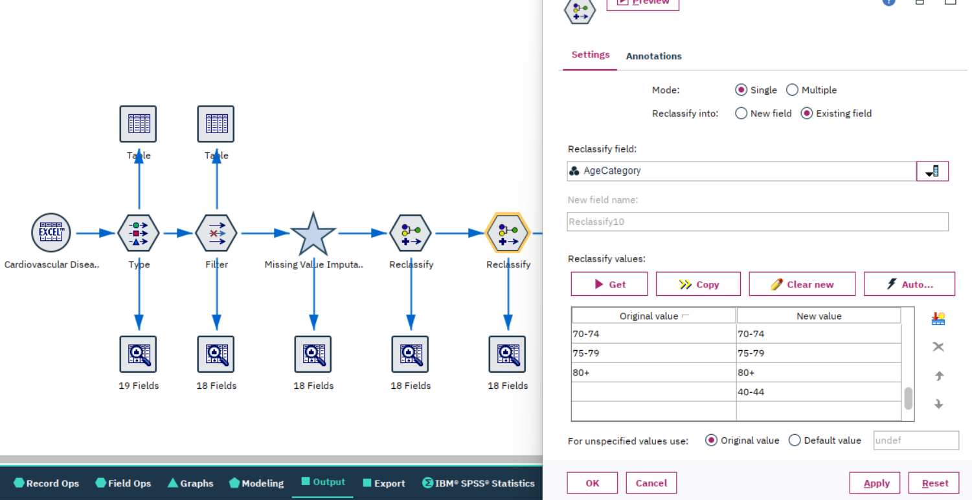

*Figure 26: Classify Age Category Column*

The two images above are the operations I performed using the reclassify node to reclassify the Diabetes and Age columns. After reclassification, you can see the situation as shown in the images below. The part framed in red at the top indicates that there are only two values in the Diabetes column, namely “yes” and “no”. In the red frame below, there are no longer any rare classes in the age distribution, demonstrating that my reclassification was effective.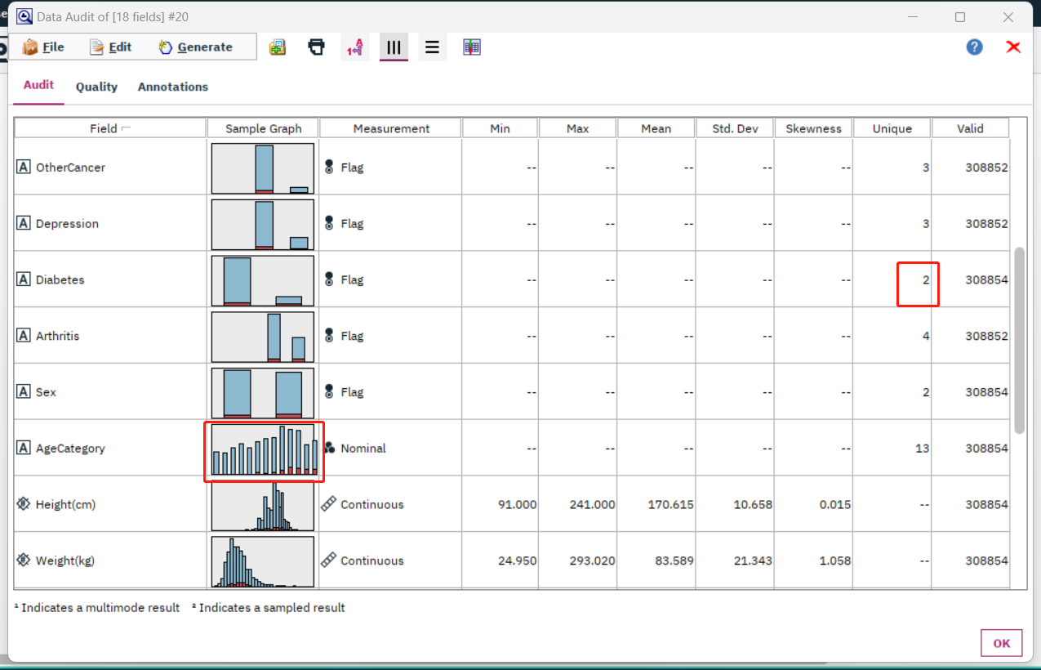

*Figure 27: Data Audit after Reclassify*

1. Empty value

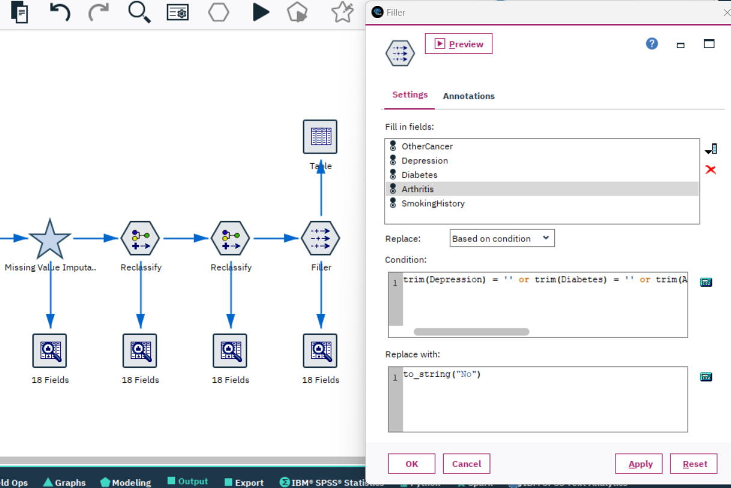

*Figure 28: filler conditions and replace setting*

The image above illustrates that I want to fill in the blank data for the five fields: Other Cancer, Depression, Diabetes, Arthritis, and Smoking History. The requirement for filling in the content is that the data value is empty, with the expression being trim($field$) = ''. Here, $field$ is to be replaced with the name of the column. The content replaced in all instances is "No."

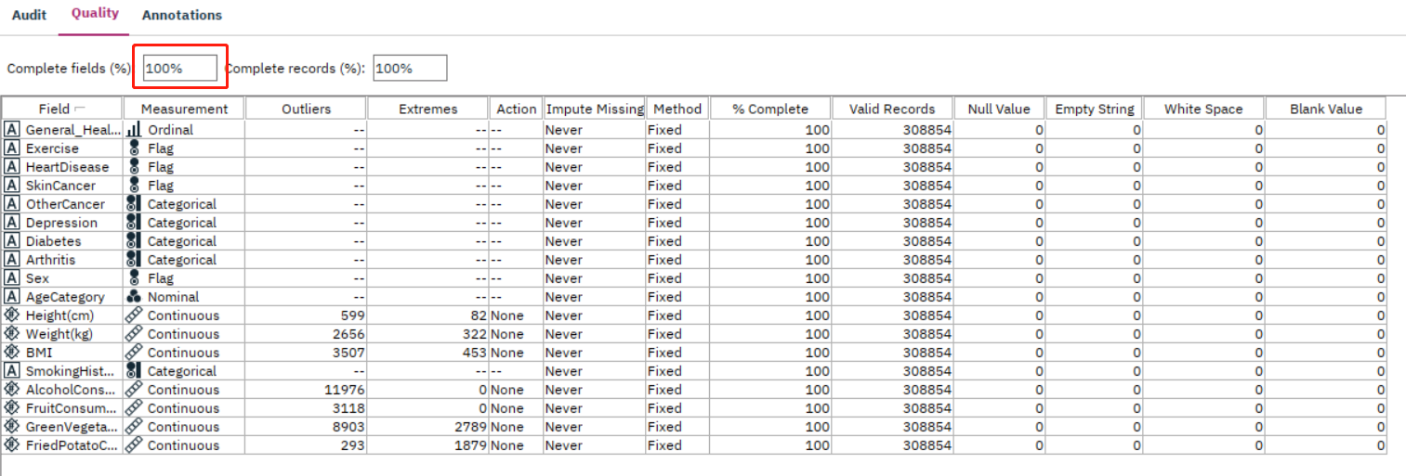

*Figure 29: Data Audit after filler*

The image above represents the state of my data so far. All of the data is complete, with no missing, blank, or null value situations..

1. Outliers and extremes

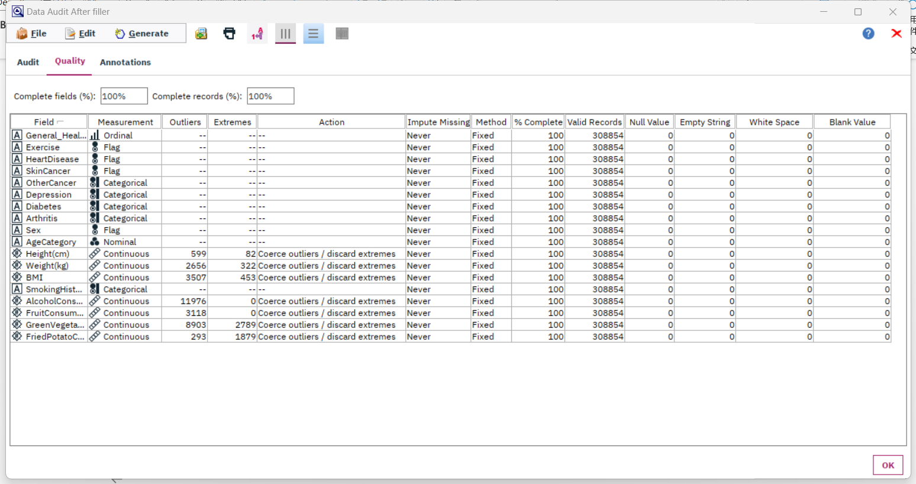

*Figure 30: Outlier SuperNode choice in audit node*

The image above shows my handling of outliers and extremes for continuous data. The current method is the most common editing approach, which is “coerce outliers/discard extremes”. If this operation does not yield a suitable model, other methods will need to be chosen to clean the data in subsequent iterations.

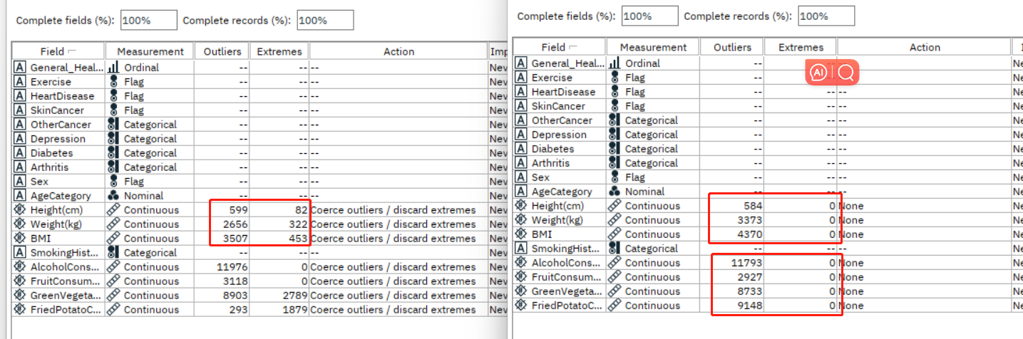

*Figure 31: Audit information after outliers and extremes action*

From the image above, we can see that after processing, the number of outliers and extremes has changed. However, the handling of outliers and extremes can generate new ones. I will need to check in subsequent iterations whether I need to deal with outliers and extremes again or only focus on specific data.

**3.3 Construct the data**

In my data, there is a field for alcohol consumption. From the illustrative image circled in red in the data audit below, we can see that a substantial portion of people have a data value of 0, indicating that they do not drink alcohol. Among those who do drink, there are significant differences in the amount consumed. Therefore, I want to categorize this lifestyle habit into two classes: drinking and not drinking. In subsequent steps, I can further subdivide among those who drink to see how the amount of alcohol consumed affects heart disease. As a result, I need to add a column for whether or not they drink alcohol.

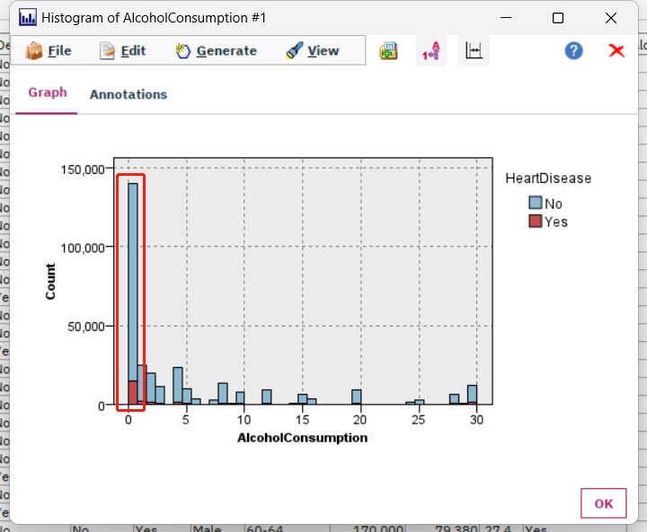

*Figure 32: Histogram circled Zero alcohol consumption*

**3.4 Integrate various data sources**

Due to the large volume of data, I have my 308,854 records stored in two different Excel spreadsheets. What I need to do now is merge these two files into one. The Excel spreadsheet for dataset part 1 contains 151,471 records, and the Excel spreadsheet for dataset part 2 contains 157,383 records.

*Figure 33: Data row numbers of Excel part 1*

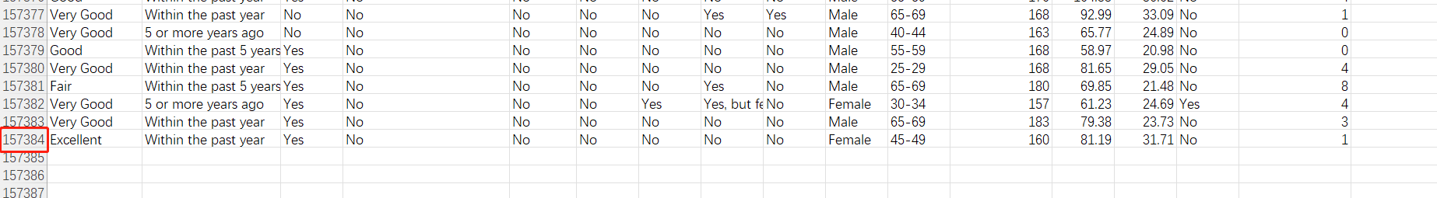

*Figure 34: Data row numbers of Excel part 2*

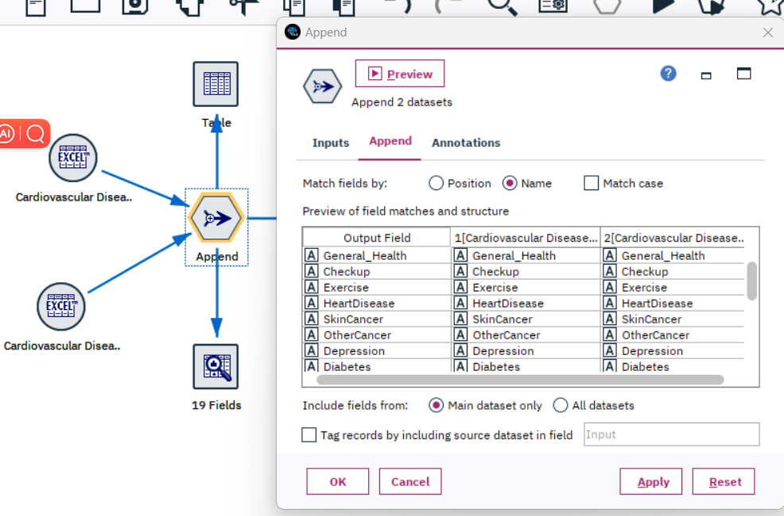

*Figure 35: Data row numbers of Excel part 2*

By using the append node, I have merged the two parts of the Excel file. As shown in the image below, the final data count remains 308,854.

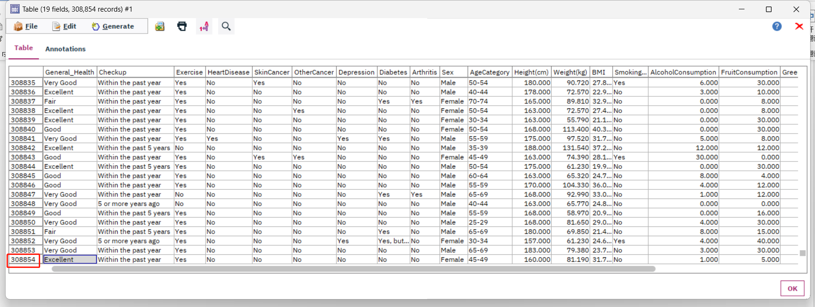

*Figure 36: Total row number in the appended table*

**3.5 Format the data as required**

In my previous section, I have already cleaned and completed the data. Now, as shown in the image below, I need to use the type node to check whether my data is of the desired data type that I wish to obtain.

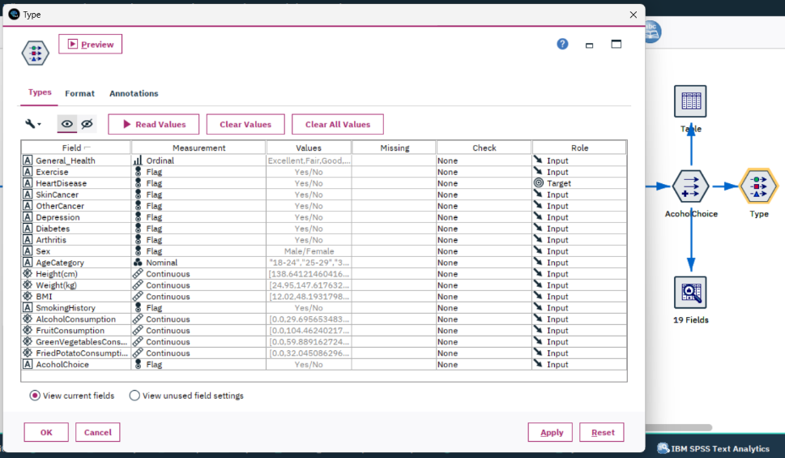

*Figure 37: Checking data types in Type Node*

**4. Data transformation**

**4.1 Reduce the data**

As shown in the image below, I can analyze the importance of various fields through the Feature Selection node.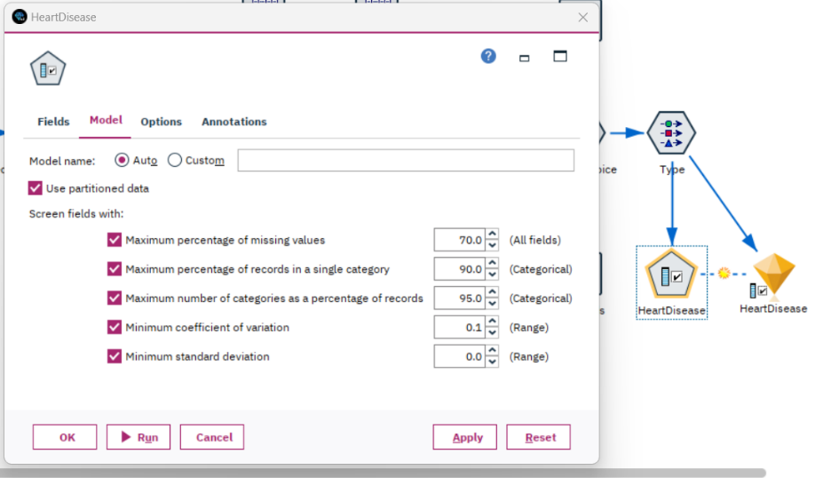

*Figure 38: Feature Selection algorithm to rank most important fields*

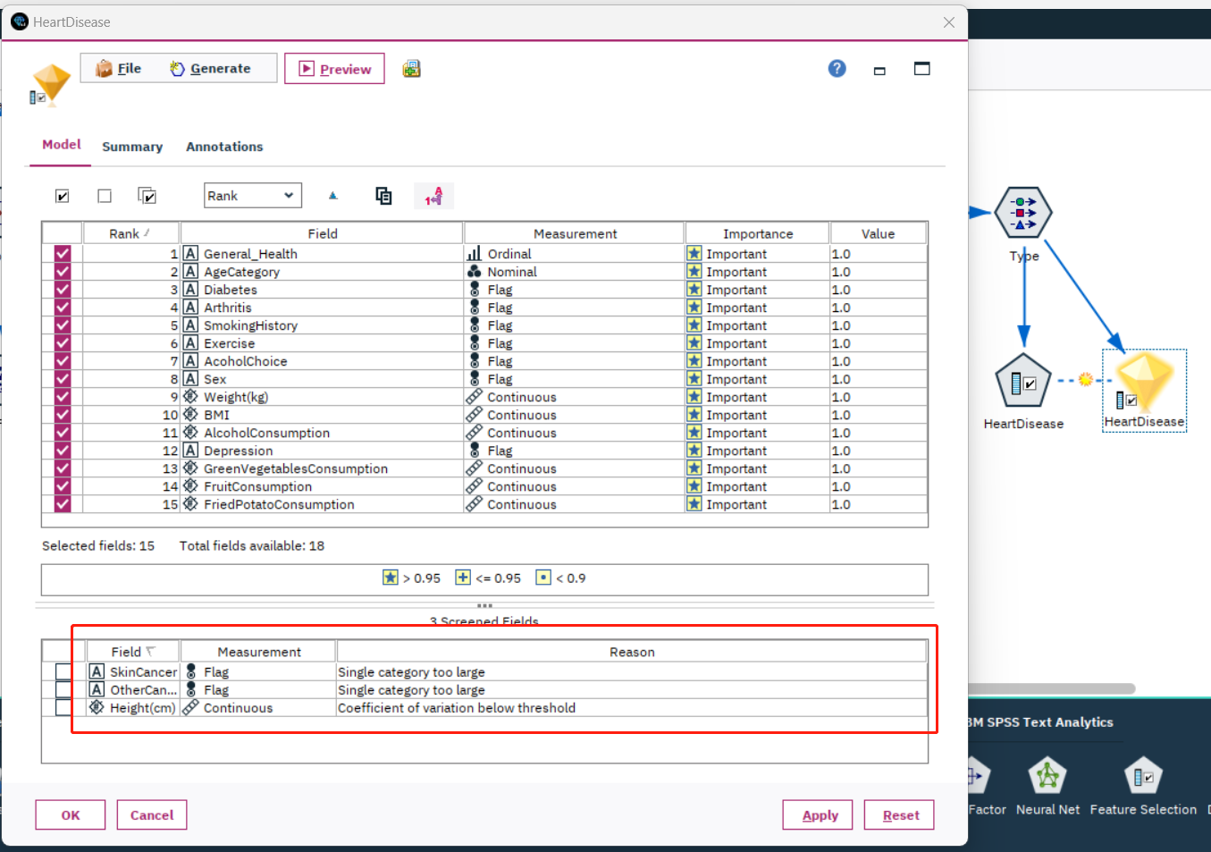

*Figure 39: Feature Selection results based on the fields’ importance*

Based on the importance analysis results in the image above, I can conclude that skin cancer, other cancer, and height are not as important as the other fields. They need to be removed. The image below shows that the fields have already been eliminated from 19 to 16 after using the filter node.

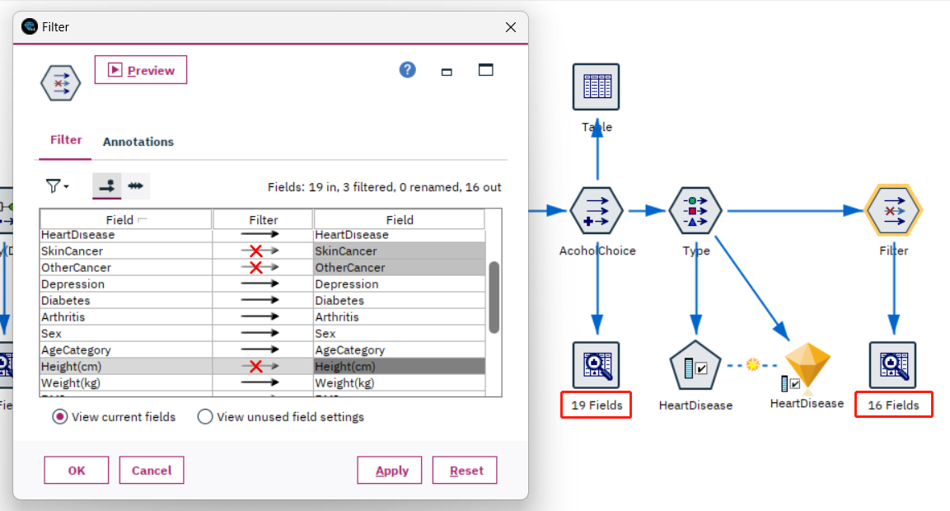

*Figure 40: Remove less important fields by using Filter node*

**4.2 Project the data**

Currently, my target field is heart disease. The data is imbalanced at the moment. As shown in the image below, the number of "No" far exceeds the number of "Yes" in the data. I need to manipulate this data to make it essentially balanced.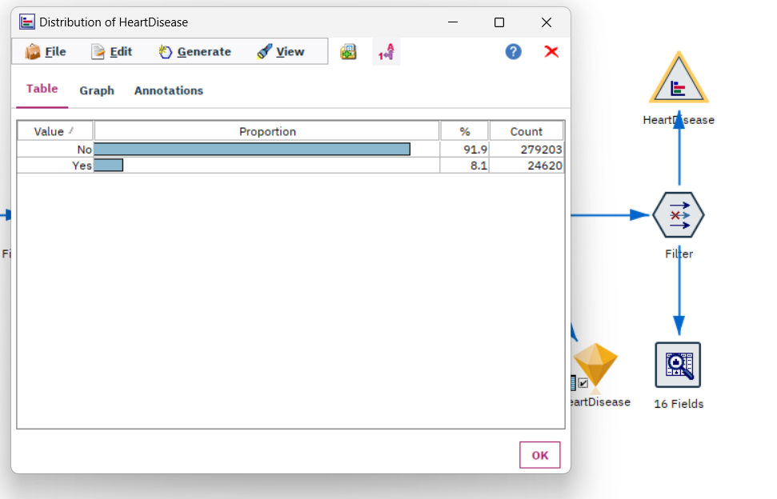

*Figure 41: Current target field distribution*

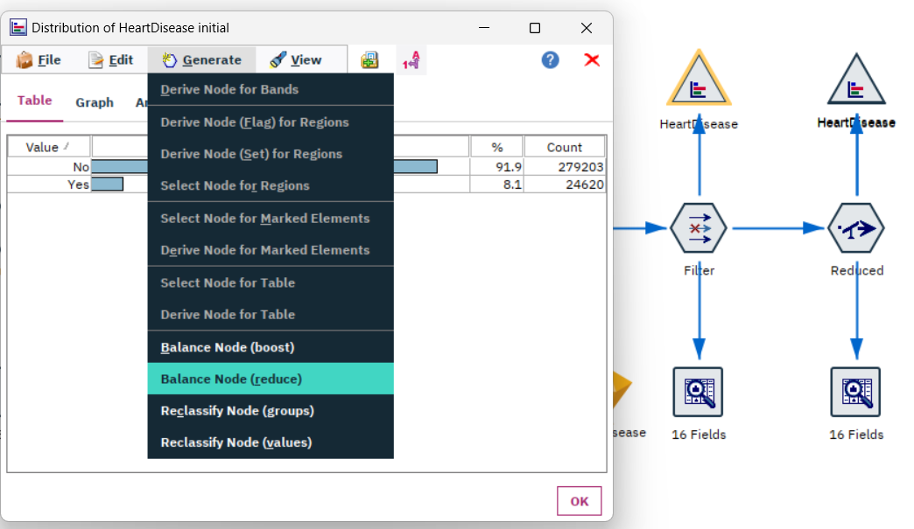

*Figure 42: Balance Node in the target field distribution*

The image above shows that the balance node in the target field's distribution is used to balance the data. Since I have a large amount of data, and the less frequent "Yes" data consists of 24,620 records, I should choose the reduce method instead of the boost method.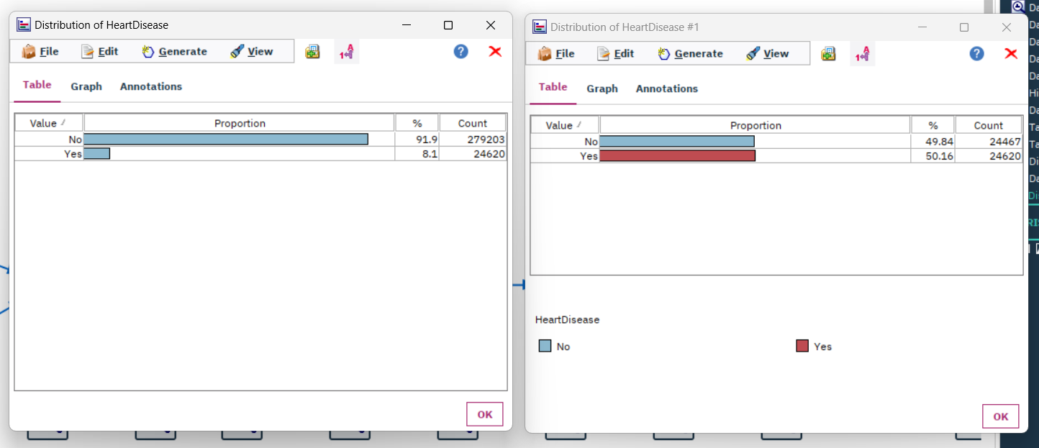

*Figure 43: Comparison of the distribution of Heart Disease before and after balance node*

The image above compares the distribution of the target field before and after balancing. It's clear that after passing through the balance node, the data has become balanced.

I have now adjusted the data, so I need to use the Feature Selection node again to check whether there is any column of insufficient importance to be removed. As shown in the image below, my examination result is that all the current columns are essential, and I don't need to take any action.

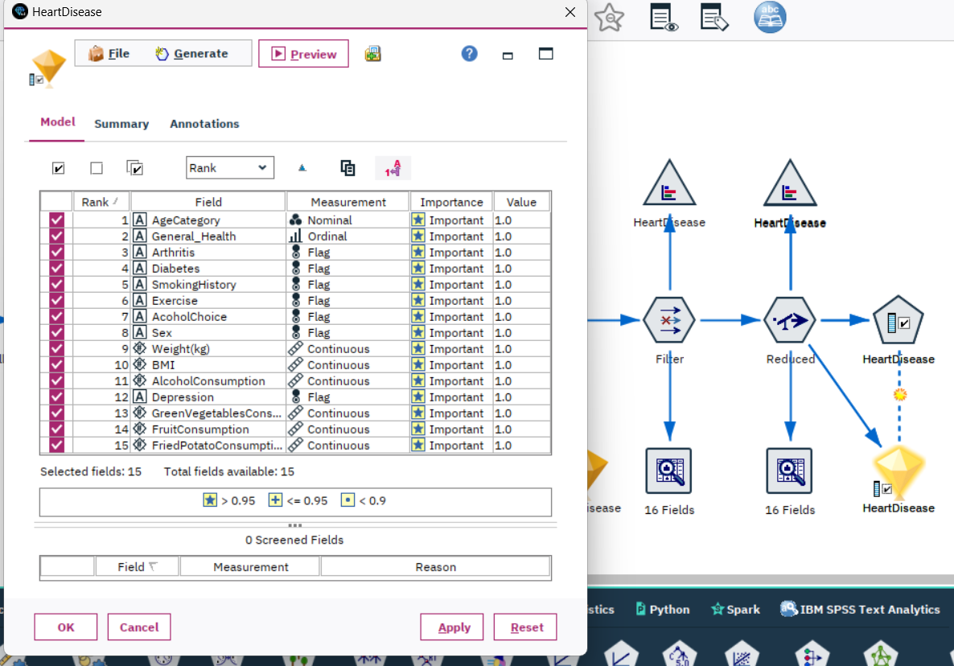

*Figure 44: Checking fields’ importance by using Feature Selection Node*

**5. Data-mining method(s) selection**

**5.1 Match and discuss the objectives of data mining (1.1) to data mining methods**

5.1.1 Data mining methods introduction

There are primary data mining methods include **Classification, Regression, Clustering, Summarization, Dependency Modeling, and Change and Deviation Detection**(Fayyad et al., 1996).

Understanding various data mining techniques and aligning them with specific objectives is pivotal to ensuring our analysis methods resonate with the anticipated output. Within the context of predicting cardiovascular disease risks, each technique offers unique strengths and limitations.

Firstly, I delved into the classification method. Classification is akin to tagging an item, pinpointing which category it fits into. When I aim to predict an individual's predisposition to cardiovascular diseases, the classification method could tag them as "high risk" or "low risk" based on their lifestyle factors. However, the caveat with this method is that it chiefly provides a label without conveying the precise probability of risk.

Subsequently, I contemplated the regression method. Regression zeroes in on discovering relationships between variables to forecast a particular numeric value. For my purpose, it could estimate the probability of cardiovascular risk rooted in lifestyle factors. While it offers a precise numeric prediction, it might not adequately expose all potential risk factors.

Clustering was another method I considered. It revolves around grouping data based on certain similarities, but it wouldn't directly offer me a risk prediction. Nonetheless, by identifying which lifestyle combinations are most prevalent, it could shed light on certain insights.

Summarization enables me to extract core patterns or trends from a voluminous dataset. Although it offers a macro perspective, it may not be tailored for individualized risk predictions.

I also looked into dependency modeling, a technique focusing on relationships and interactions within the data. This could reveal which lifestyle factors are most correlated with elevated cardiovascular risks, adding depth to my predictions.

Lastly, the change and deviation detection method would offer me real-time alerts when data deviates from previous patterns. This is instrumental for tracking abrupt lifestyle changes and potential risk surges, but it leans more towards monitoring rather than predicting.

In conclusion, each data mining technique possesses its applicability and constraints. The crux lies in strategically combining these methods to furnish me with the most comprehensive and accurate assessment of cardiovascular disease risks.

**5.2 Select the appropriate data-mining method(s) based on discussion**

Predicting the onset of cardiovascular diseases based on diverse lifestyle choices is a complex endeavor. The interplay of data ranging from dietary habits to medical conditions like diabetes provides a mosaic of information. Deciphering this to forecast health outcomes demands a multifaceted approach. In this exploration, we delve into three pivotal modeling methodologies that not only offer predictive insights but also unravel the intricate relationship between lifestyle and heart health.

When confronted with the crucial task of predicting the risk of cardiovascular diseases based on different lifestyle choices, my initial inclination is to deploy the **classification** method. Now, I am holding a plethora of data on individuals, from the presence or absence of diabetes to their fruit intake. The challenge lies in determining, based on these data points, whether they are likely to suffer from cardiovascular diseases in the foreseeable future or not. This is where classification thrives. Through this approach, I can assign a distinct predictive label for each individual, enabling me to provide tailored advice and preventive measures for these individuals.

For my target variable which is of the flag type, my initial inclination is to use classification methods. However, I'm aware that logistic regression—a specific type of **regression**—is designed explicitly for handling binary or flag-type outputs. The purpose of logistic regression isn't to predict a continuous output but rather to estimate the probability of an event occurring. This means its output is a value between 0 and 1, representing the likelihood of the event. For instance, I can employ logistic regression to gauge the probability of someone developing cardiovascular diseases and might obtain an output like 0.65, or 65%. So, when I'm confronted with a flag-type target and I'm interested in the odds of an event taking place, I'd opt for logistic regression. If I were dealing with a continuous target variable, like predicting house prices or stock values, I'd consider methods like linear regression. In my current situation, logistic regression is highly suitable. It can not only predict the likelihood of an individual developing cardiovascular diseases but also categorize it into two classes based on a threshold I set, such as 0.5, designating them as "at risk" or "not at risk".

Yet, grounding all these predictions on a robust theoretical foundation is imperative. This calls for a profound comprehension of the genuine relationship between lifestyle choices and cardiovascular risk. And this is where **dependency** modeling comes into play. Through this modeling method, I can elucidate which factors bear the strongest correlation with cardiovascular risk, or if a particular factor amplifies the risk only under specific conditions. For instance, I might discover that a high sugar intake correlates with an increased risk of cardiovascular diseases only in conjunction with certain lifestyle combinations. Such profound insights not only fortify the foundation of my predictions but also empower me to dispense more targeted health advisories to the public.

The intricate dance of predicting cardiovascular risks based on lifestyle hinges on a multifaceted approach. Through the nuanced application of classification, regression, and dependency modeling, we achieve a holistic view that ranges from broad risk categorizations to precise probability estimations. Such a comprehensive approach ensures that individuals are not just informed of potential risks, but they are also empowered with detailed knowledge, leading to informed health decisions and targeted interventions.

**6. Data-mining algorithm(s) selection**

**6.1 Conduct exploratory analysis and discuss**

After analyzing the preliminary data mining methods, I've tailored my approach to three essential techniques pertinent to my research goals: Classification, Regression, and Dependency Modeling. The crucial next step involves leveraging SPSS software to pinpoint and implement the optimal data mining algorithms. This will, in turn, refine the accuracy and reliability of cardiovascular disease risk predictions. Given the robust capabilities and versatility of SPSS, I'm inclined to utilize its specialized nodes to enact the chosen algorithms. To ensure the selected algorithms resonate seamlessly with my data and objectives, I plan to delve deeper into the nuances of data characteristics, research targets, and SPSS functionalities in the subsequent steps.

I'll first use the Partition node to determine the training and test data percentages. In this step, I use the classic 80/20 method.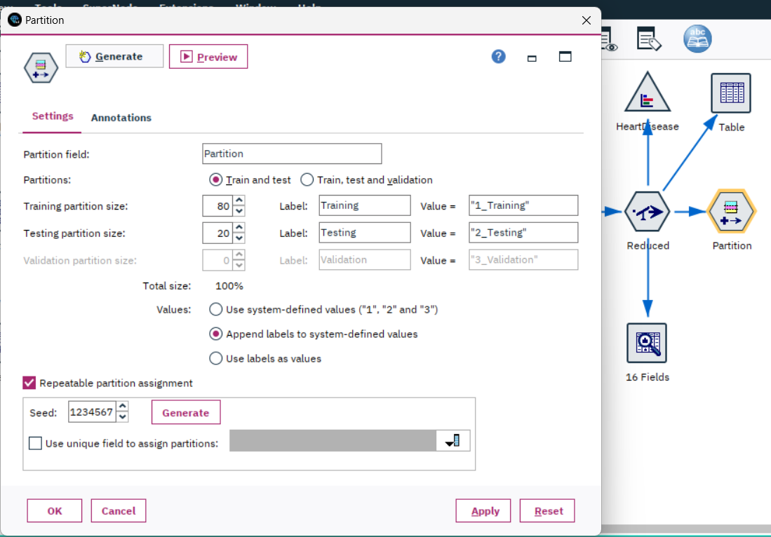

*Figure 45: Partition Settings*

1. Classification:

To predict cardiovascular disease risk categories, I've settled on the Decision Tree algorithm.

Within SPSS Modeler, the "C&R Tree" node serves as the conduit for deploying the CART algorithm. My rationale for choosing the C&R Tree encompasses

1. Flexibility: It's adept at managing both classification and regression issues, aligning flawlessly with my data structure.
2. Interpretability: The outcomes rendered by the C&R tree are lucid, shedding light on the precise split points of variables and their correlative category outputs.

Upon executing the "C&R Tree" node, my focal points would be:

1. Tree Depth: An ideal tree shouldn't be overly intricate, guarding against overfitting.
2. Accuracy: The accuracy of the model indicates how accurate the model performance is in predicting data, including the wrong “Yes” and wrong “No” percentages.
3. AUC value: The higher the AUC, the better the performance of the classifier. An AUC greater than 0.5 indicates that the model possesses some classification capability, and the closer it is to 1, the better the model's classification ability.

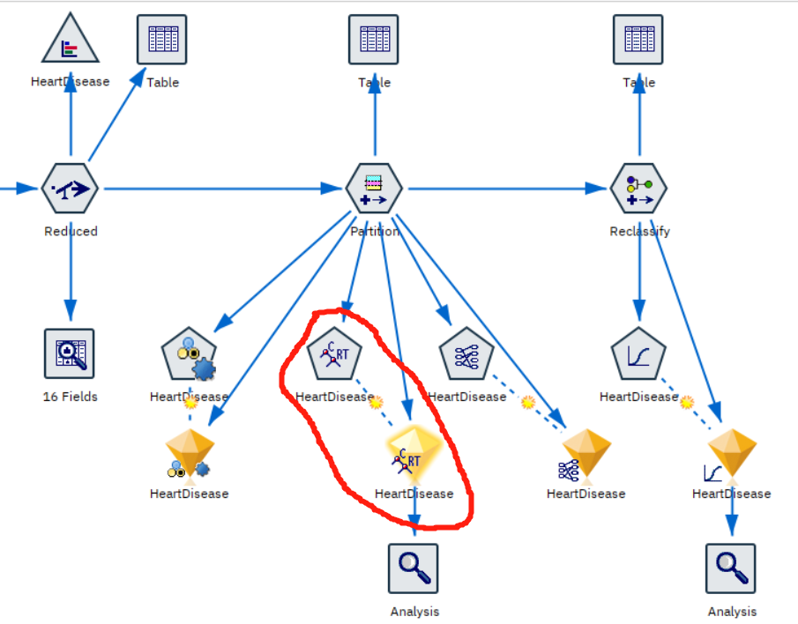

*Figure 46: Stream output of C&R algorithm*

The graph above shows the stream output of the C&R algorithm. The area in the red circle is the nugget of the C&R algorithm. The settings of the model are shown below.

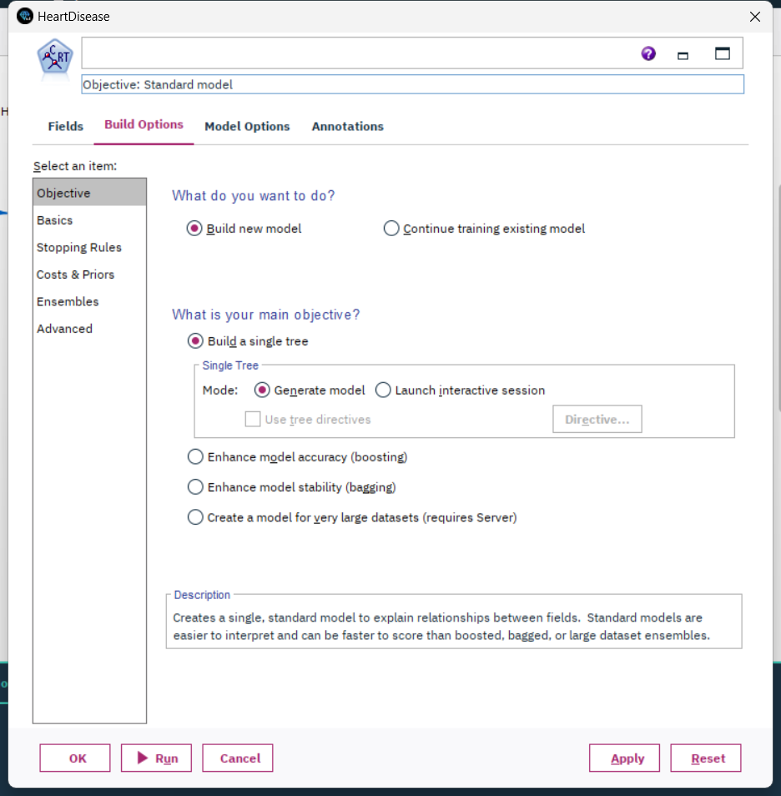

*Figure 47: Settings of C&R model*

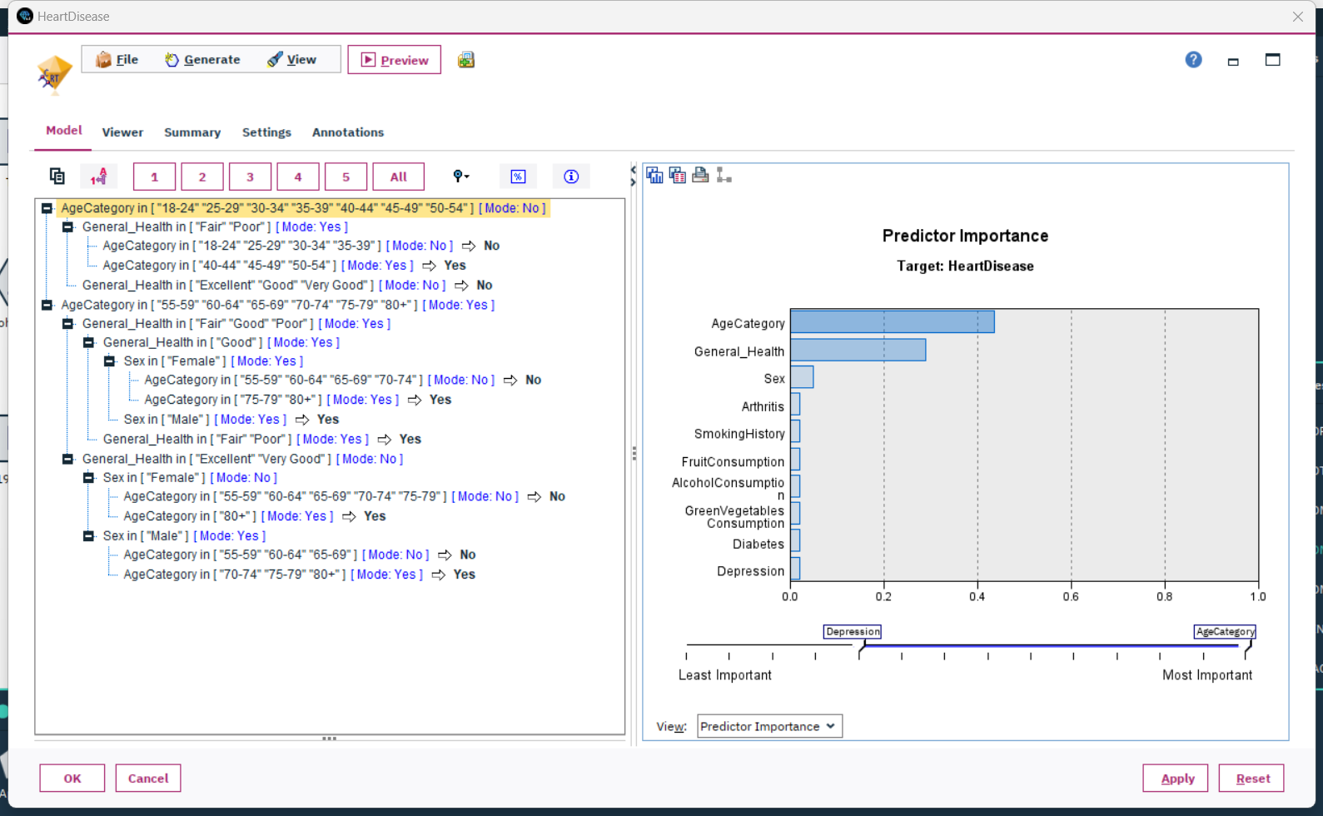

*Figure 48: C&R model output of decision tree rules*

The graph shown above is the C&R model output of decision tree rules. And the C&R model accuracy and performance are shown below.

=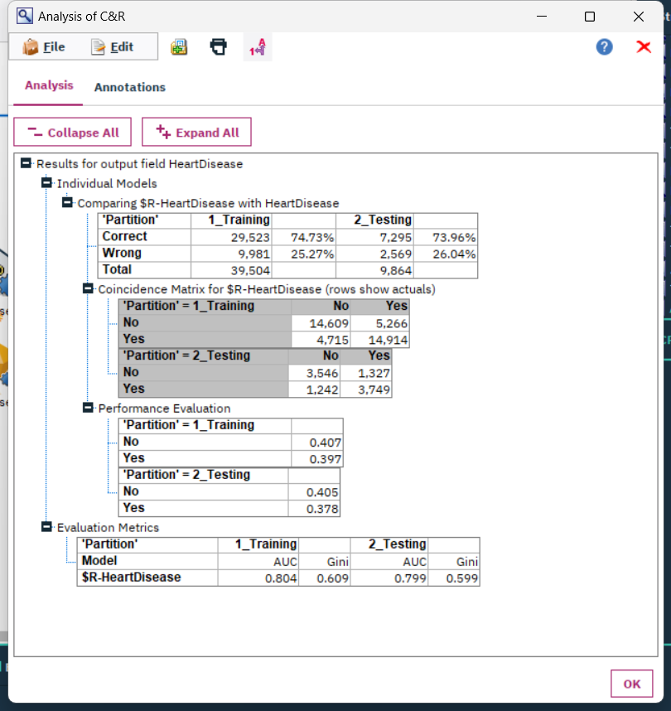

*Figure 49: C&R model accuracy and performance*

As we can see above. The accuracy of training data is 74.73%, and the accuracy of testing data is 73.96%. The AUC for training data is 0.804 and the AUC for testing data is 0.799. In the Training data, the wrong “Yes” is 4715/(4715+14609)=24.39%, and the wrong “No” is 5266/(5266+14914)=26.10%. In the Testing data, the wrong “Yes” is 1242/(1242+3546)=25.95%, and the wrong “No” is 1327/(1327+3749)=26.15%.

1. Regression:

As I have discussed above, the logistic regression algorithm is designed explicitly for handling binary or flag-type outputs. Within SPSS Modeler, I selected the "Logistic Regression " node. My reasons for choosing this node include:

1. Adaptability: Although logistic regression is primarily used for binary classification problems, its output in terms of probability values can be viewed as a continuous risk score, indicating the likelihood of someone developing cardiovascular diseases.
2. Interpretability: The output from logistic regression provides probabilistic weights for each predictor, allowing for a clear understanding of the significance of each variable in the prediction.
3. Probability Output: It delivers a probability for each observation, offering insight into the confidence of the prediction.

When running the "Logistic" node, I would pay special attention to the following outputs:

1. Coefficients: These inform us about how each predictive variable influences the probability of the response variable. A positive coefficient indicates a positive relationship between the predictor and the response, while a negative coefficient signifies an inverse relationship.
2. Accuracy: The accuracy of the model indicates how accurate the model performance is in predicting data, including the wrong “Yes” and wrong “No” percentages.
3. AUC value: The higher the AUC, the better the performance of the classifier. An AUC greater than 0.5 indicates that the model possesses some classification capability, and the closer it is to 1, the better the model's classification ability.

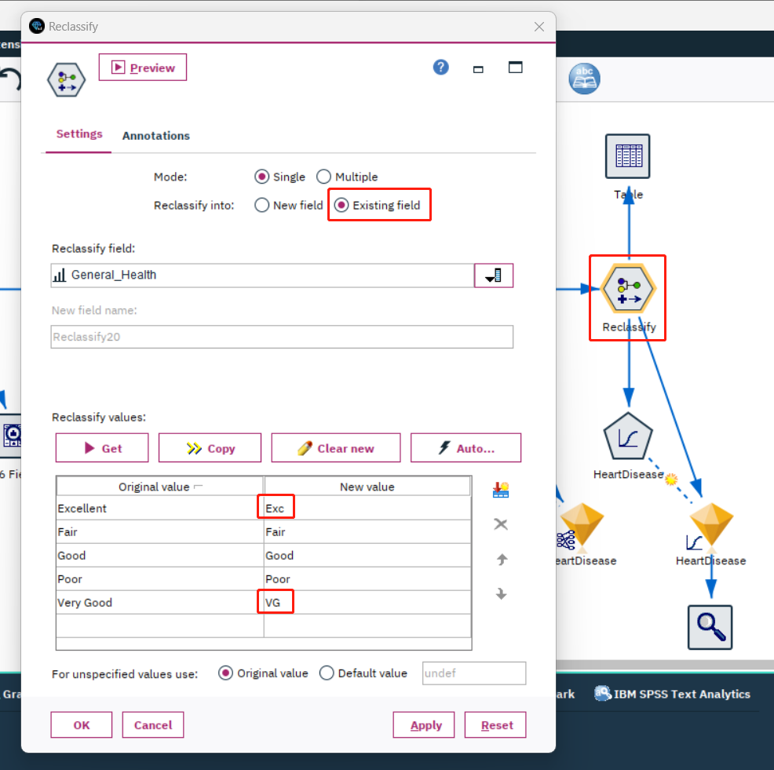

*Figure 50: Field value rename using Classify node*

Due to the excessively long field values "Excellent" and "Very Good" in the 'General_Health' column, it's not possible to run the logistic regression model. Therefore, before running the model, the data values "Excellent" and "Very Good" in the 'General_Health' column need to be renamed. The operation is shown in the figure above. The table after the modifications is as follows.

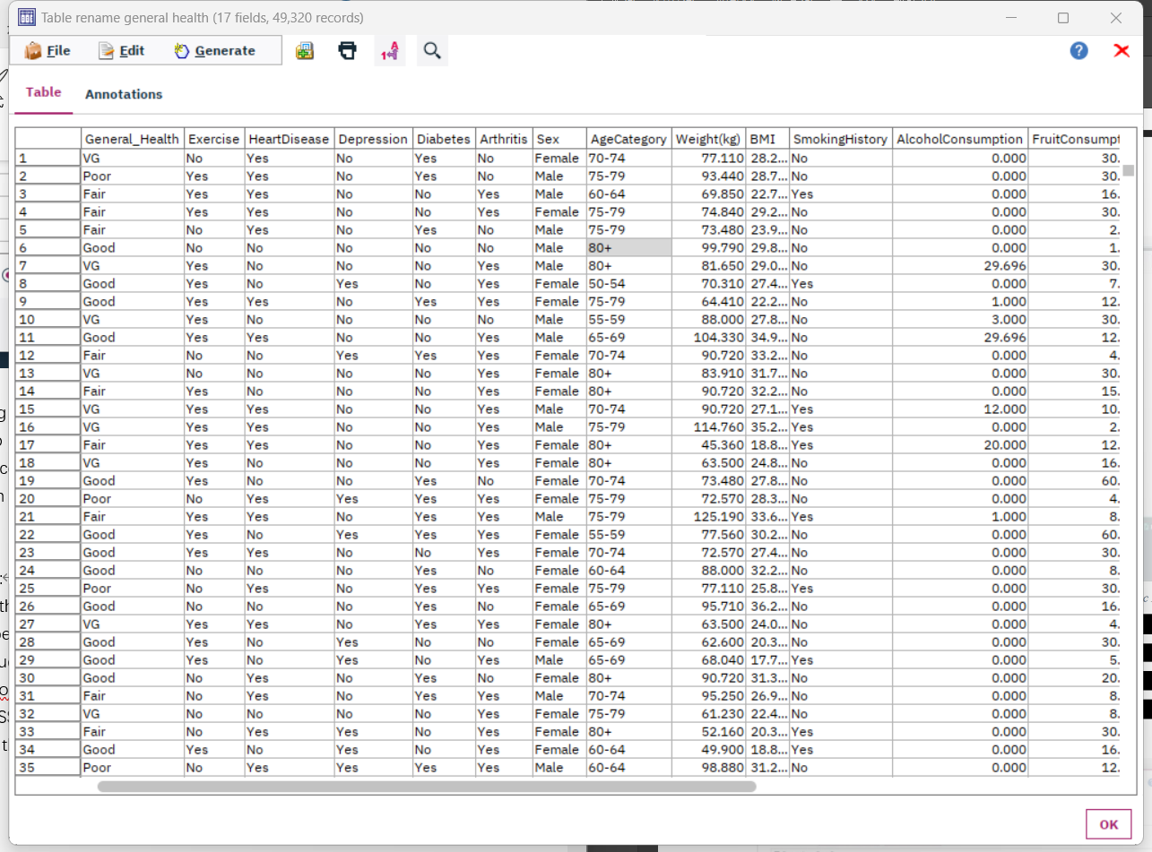

*Figure 51: Table value after rename*

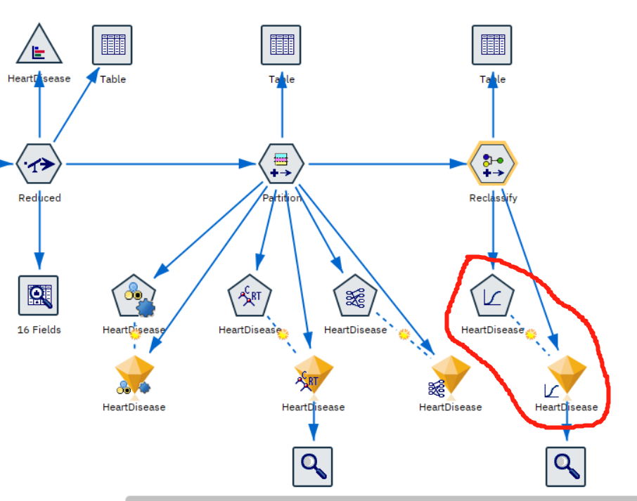

*Figure 52: Stream output of Logistic Regression algorithm*

The graph above shows the stream output of the Logistic Regression algorithm. The area in the red circle is the nugget of the Logistic Regression algorithm. The settings of the model are shown below.

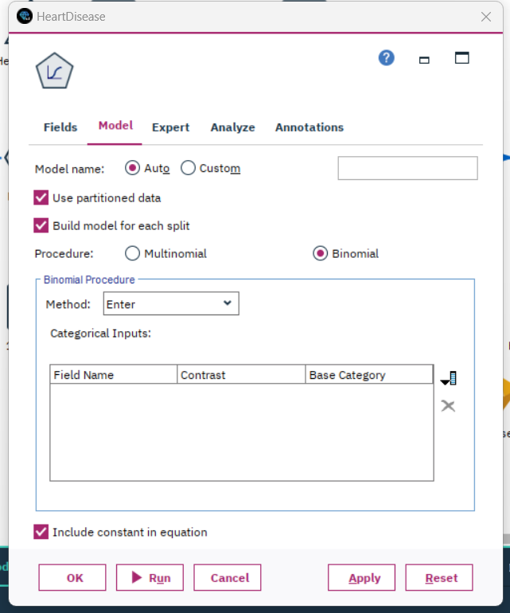

*Figure 53: Settings of Logistic Regression model*

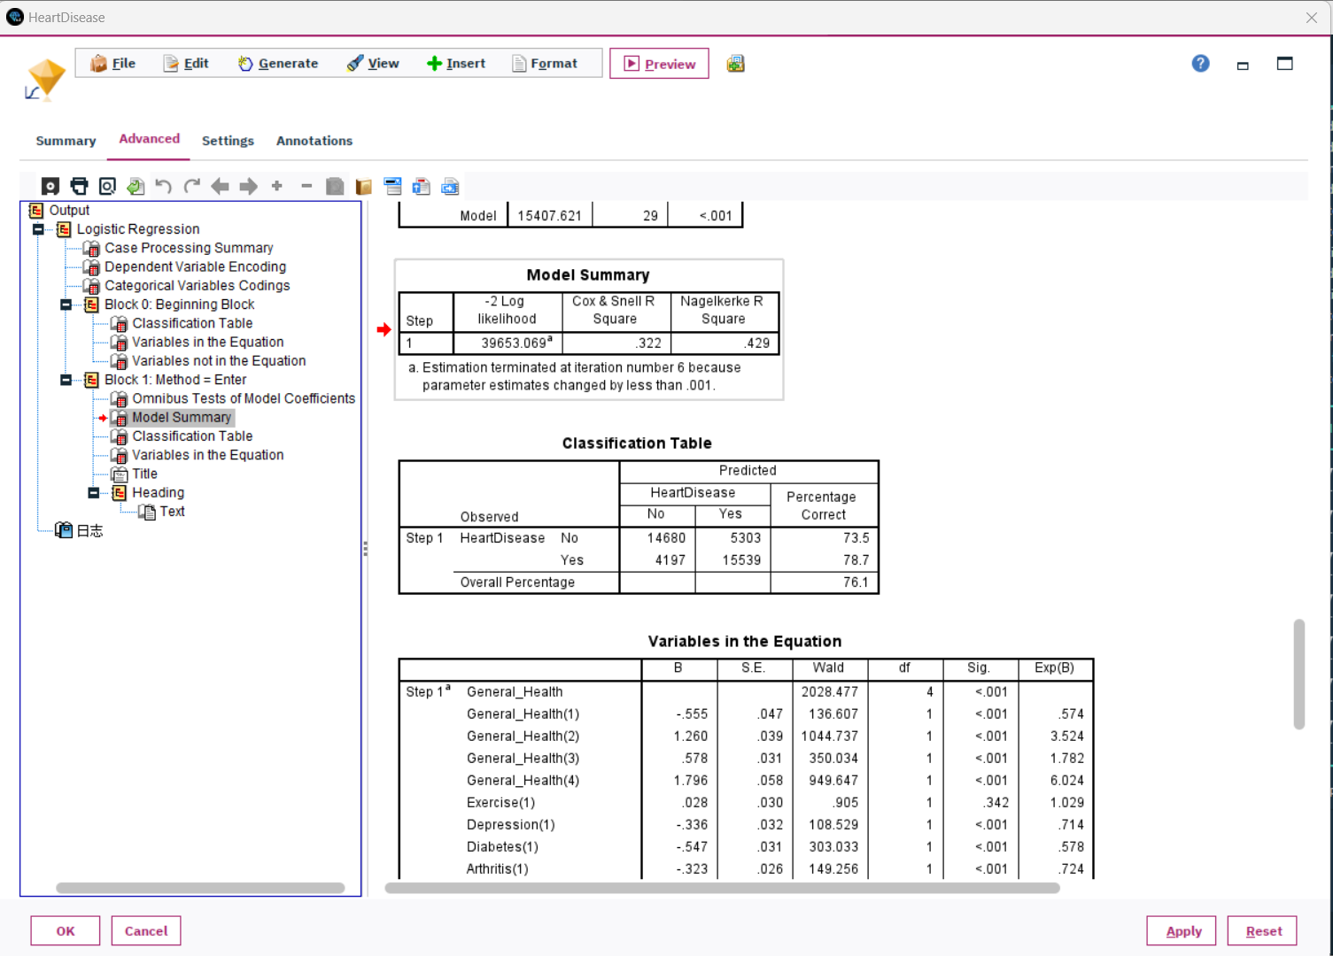

*Figure 54: Summary of Logistic Regression model*

The graph shown above is the Logistic Regression model summary and relevant information. And the Logistic Regression model accuracy and performance are shown below.

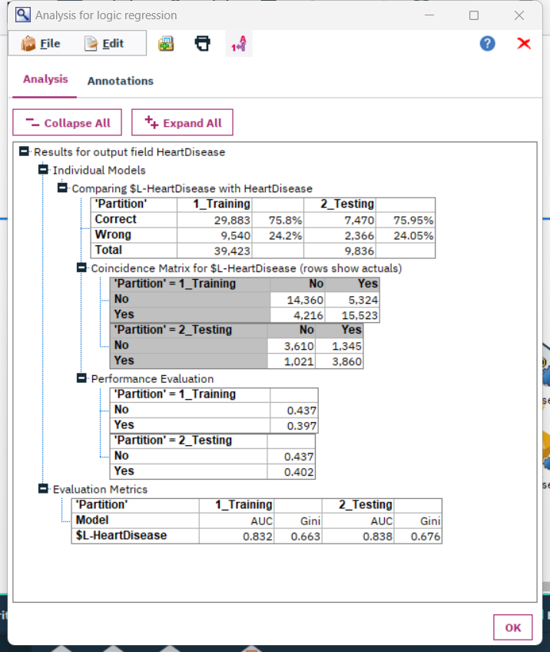

*Figure 55: Logistic Regression model accuracy and performance*

As we can see above. The accuracy of training data is 75.8%, and the accuracy of testing data is 75.95%. The AUC for training data is 0.832 and the AUC for testing data is 0.838.

In the Training data, the wrong “Yes” is 4216/(4216+14360)= 27.07%, and the wrong “No” is 5324/(5324+15523)= 25.54%. In the Testing data, the wrong “Yes” is 1021/(1021+3610)= 22.06%, and the wrong “No” is 1345/(1345+3860)= 25.84%.

1. Dependency Modeling:

My choice veers towards the Apriori algorithm for discerning association rules within the data. In SPSS, this can be materialized through the "Apriori" node. The underpinning reasons for this choice include:

1. Broad-based: The Apriori algorithm unearths a plethora of association rules.
2. Filtering Capability: SPSS permits setting minimum support and confidence thresholds, ensuring the quality of the outcome.

Upon triggering this node, my scrutiny will revolve around:

1. Support: Reflects the frequency of the rule within the dataset.
2. Confidence: Depicts the rule's precision.
3. Lift: Gauges the rule's utility. A lift greater than 1 implies the rule's superiority over random predictions.

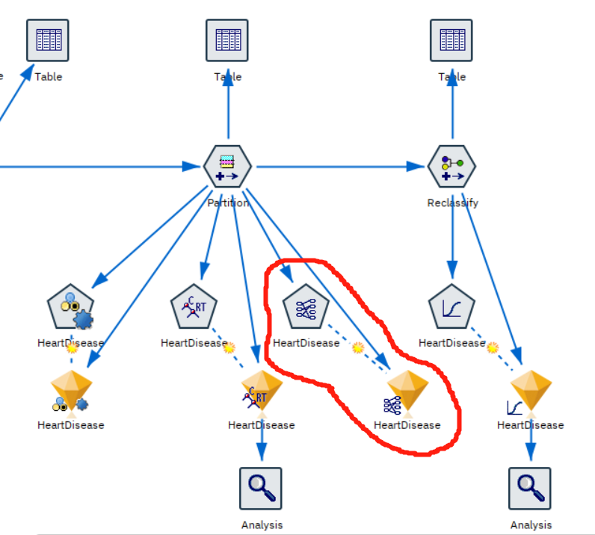

*Figure 56: Stream output of Apriori algorithm*

The graph above shows the stream output of the Apriori algorithm. The area in the red circle is the nugget of the Apriori model. The settings of the model are shown below.

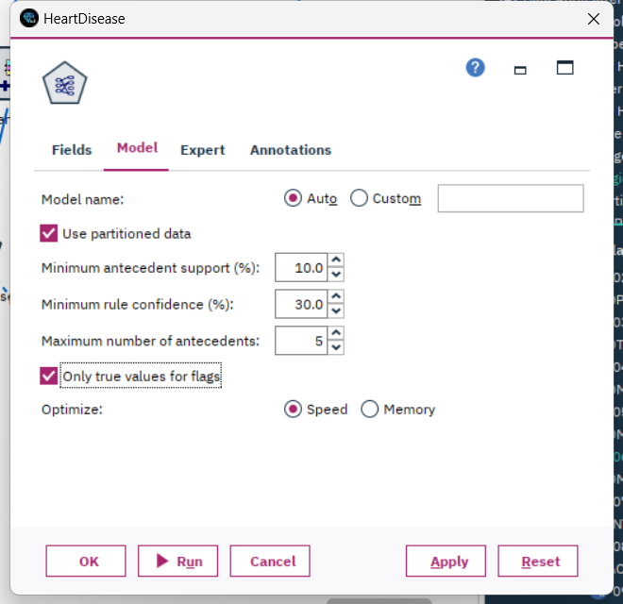

*Figure 57: Settings of Logistic Regression model*

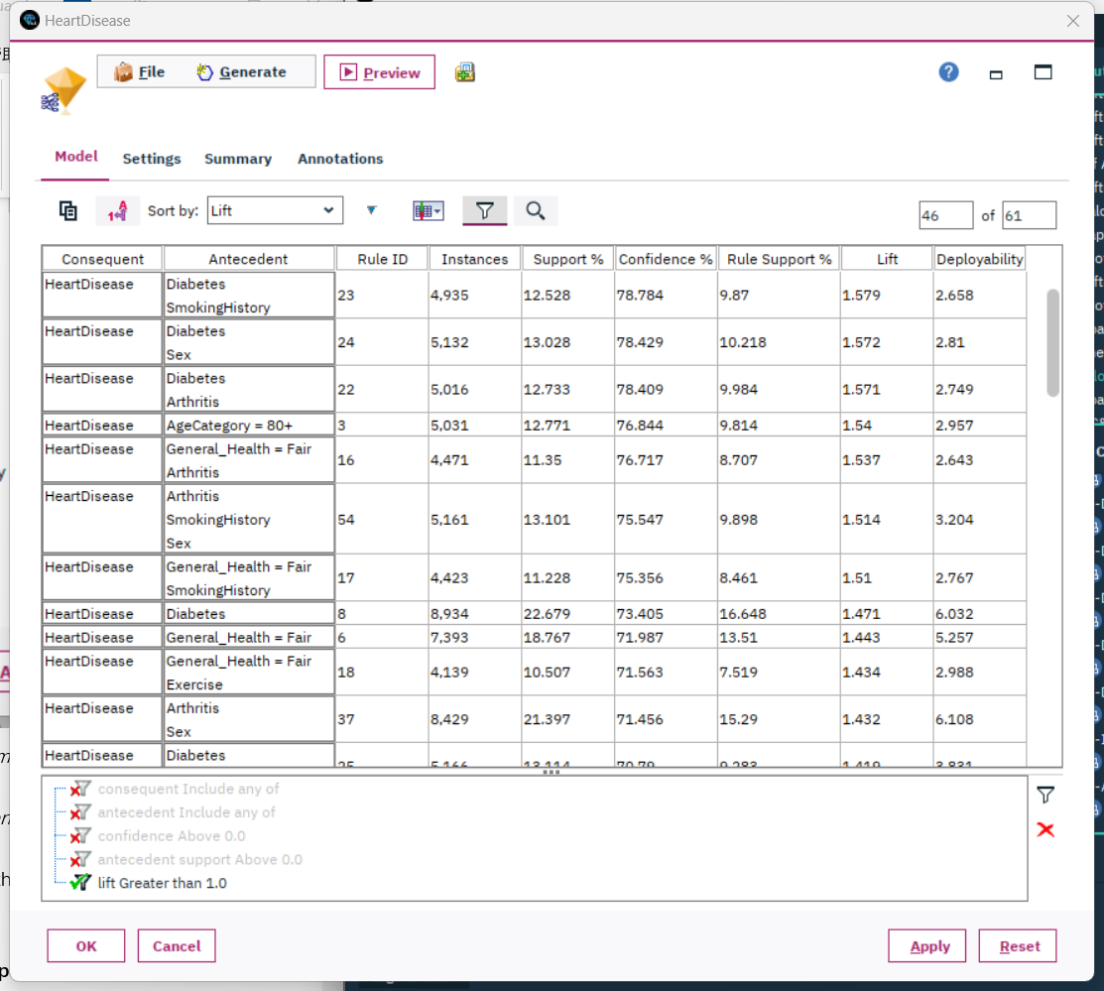

*Figure 58: Results of Apriori model descending sorting by Lift*

The graph above indicates the results of the Apriori model. I filtered out the results whose lifts are lower than 1.0. And the results are descending sorted by Lift.

**6.2 Select data-mining algorithms based on discussion**

As mentioned in step 6.1, I chose three different algorithms. They are the C&R tree, logistic regression, and Apriori. Based on the accuracy and AUC analysis of the data, I can observe that the accuracy and AUC values for the logistic regression algorithm are superior to the C&R tree. Therefore, I am inclined to choose the logistic regression algorithm. To validate this choice, I used the 'auto classifier' node in the model for automatic calculation to compare different classification models, verifying whether logistic regression is the best. This can be seen in the figure below, highlighted by the red circle.

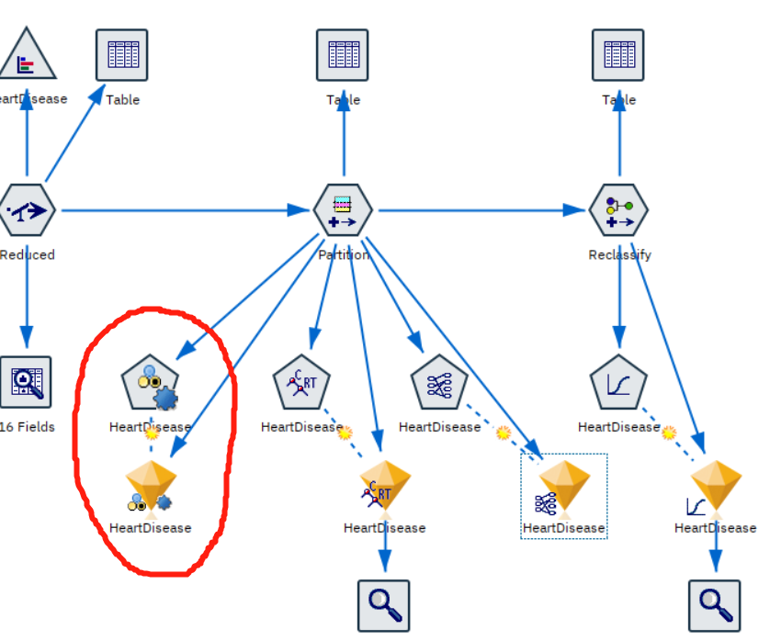

*Figure 59: Stream output of Auto Classifier node*

After executing the Auto Classifier node, the results are as follows. The Auto Classifier node has selected the top five models based on the current data conditions. In the figure below, I've arranged them in descending order based on AUC. I chose to use AUC for ranking because, compared to other metrics (such as accuracy), AUC is not dependent on a specific decision threshold. This makes it very useful for evaluating, comparing, and selecting models. Clearly, logistic regression ranks first. This result confirms that my previous choice was correct.

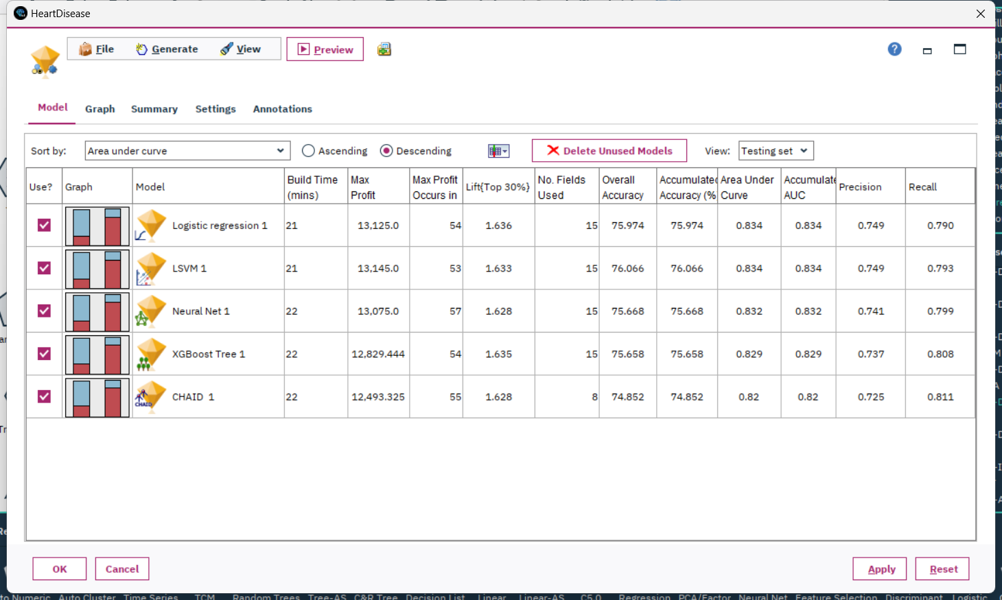

*Figure 60: Top 5 classify models chosen from Auto Classifier node*

Additionally, regarding the Apriori algorithm, I plan to supplement it within the list of algorithms. This is because, through this algorithm, I can understand which lifestyles or combinations of lifestyles impact the onset of heart disease, rather than merely arriving at a binary conclusion. This further helps in achieving my Technical Goal.

Therefore, in the subsequent steps, I will use both logistic regression and Apriori algorithms to accomplish my research objectives.

**6.3 Build/Select appropriate model(s) and choose relevant parameter(s)**

Based on step 6.2, I have already chosen two algorithms. This step involves building and running models based on my selections.

Firstly, I partitioned the prepared data into two categories: one being the training set, and the other the testing set, as shown in the figure below. I allocated 75% of the data for training and designated 25% as the testing set.

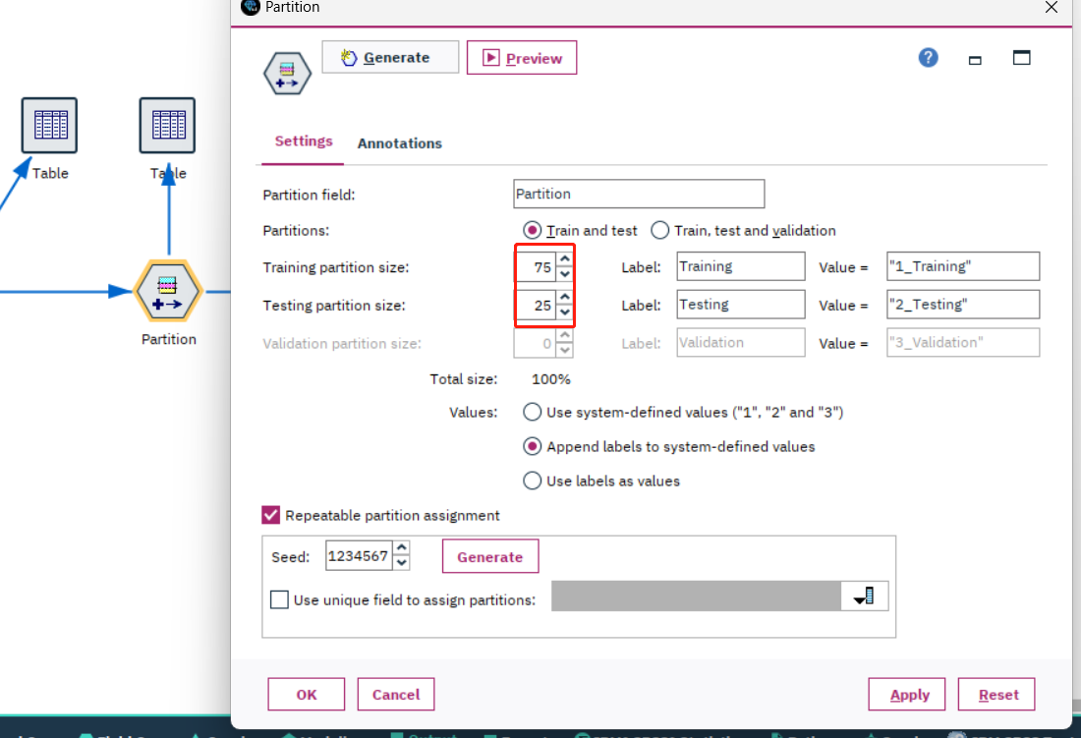

*Figure 61: Settings of Partition node*

Consequently, certain values in the "General_Health" column of the data cannot be modeled. After this partition, I renamed the data, as mentioned in Step 6.1. Refer to the figure below.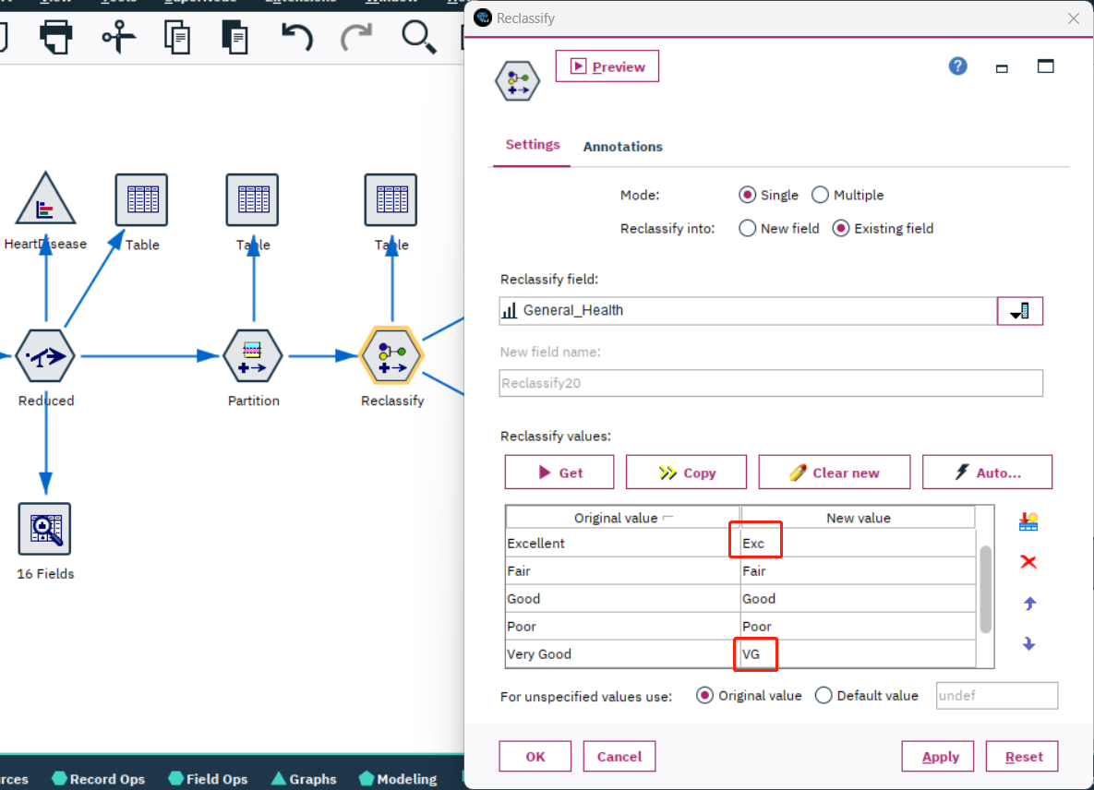

*Figure 62: Rename of the “General_Health” field*

Afterward, I processed the data through the 'select' node, categorizing it based on the partition results. This separated the testing data and training data into two distinct sets. Refer to the figure below.

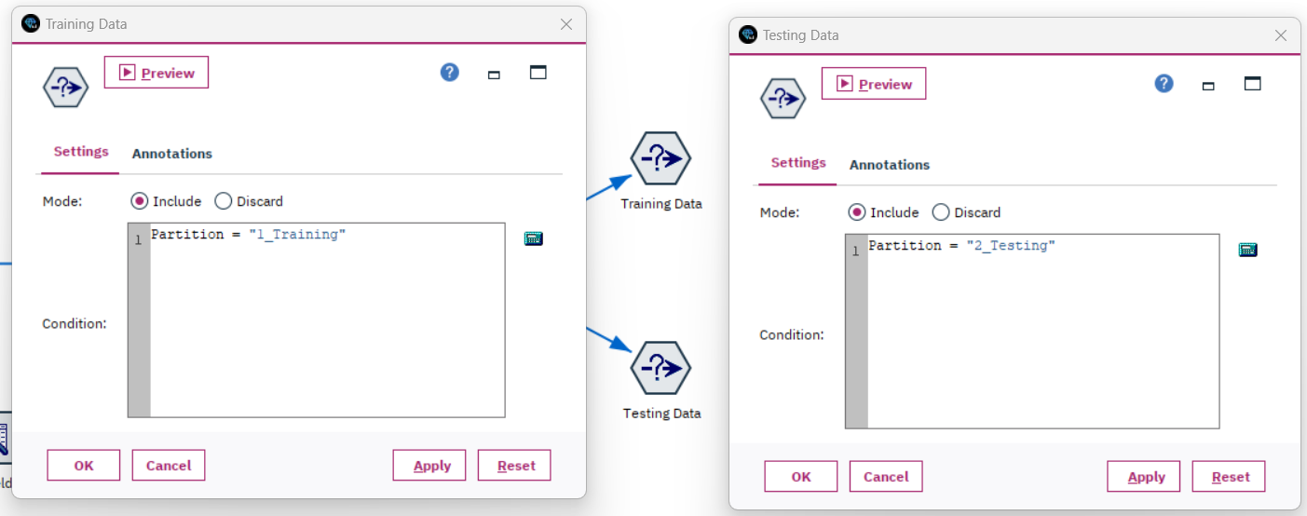

*Figure 63: Separate Data set into training set and testing set*

Next, I used the selected training set data to build the models. I employed two different models: one being logistic regression and the other Apriori.

The first one is the Logistic Regression model. As I shown below.

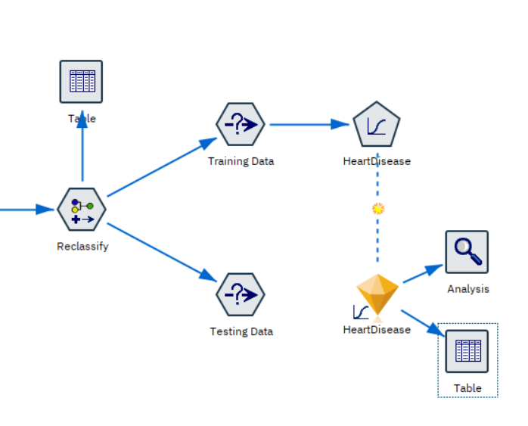

*Figure 64: Build Logistic Regression model*

The parameter settings for Logistic Regression model are as follows. I primarily used the model's default settings, only adjusting the 'procedure'. Since my outcome is binary, I chose 'Binomial'. This can be seen in the figure below, highlighted by the red circle.

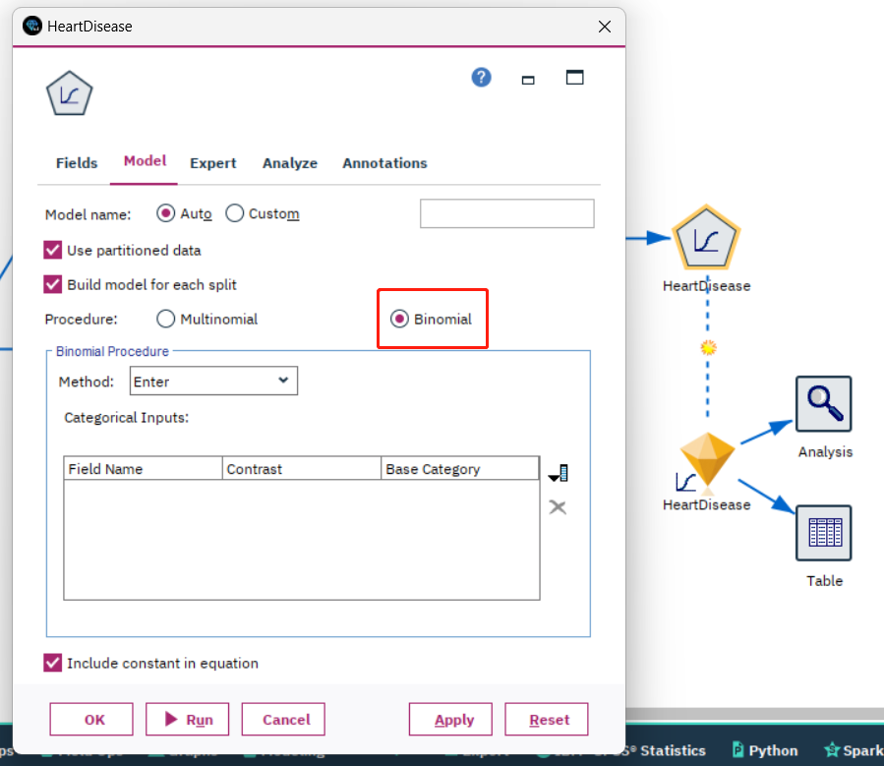

*Figure 65: Parameter setting for Logistic Regression*

After building the model using the training set, I need to evaluate its performance using the testing data set. As shown in the figure below, I connect the separated test data to the model. When I run the analysis node in the subsequent steps to assess the model, I will be able to see the accuracy of the model built with the training set data when applied to the testing set data, thereby evaluating its performance.

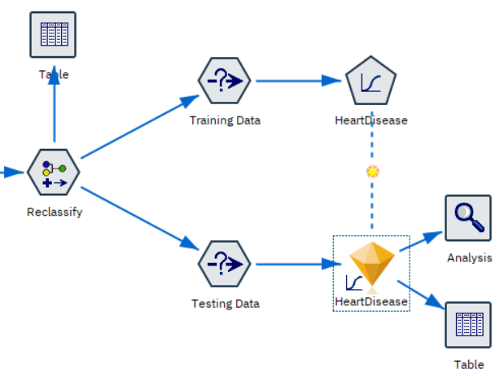

*Figure 66: Testing data connected to evaluate Logistic Regression model*

Secondly, I constructed the Apriori model. Since Apriori is an Association model, it cannot be tested for accuracy with the test set in the same way as the Logistic Regression model. Therefore, I don't need to use separate training and testing datasets to build the model. As illustrated in the figure below, I can use the reclassified data to construct the model.

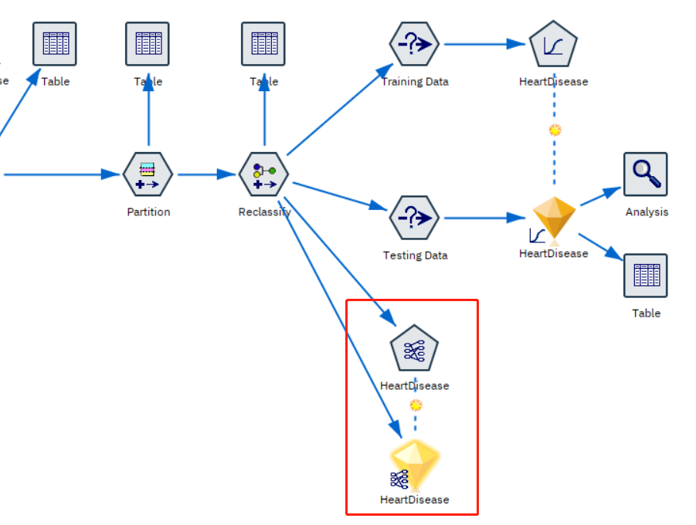

*Figure 67: Build Apriori model*

The parameter settings for Apriori model are as follows. I primarily used the model's default settings, only adjusting the 'Minimum Rule Confidence’. If this value is set too high and there is data that doesn't meet the threshold, the modeling fails. Therefore, I lowered this value. As shown in the red circle in the figure below, I adjusted it to 20%. This way, most modeling attempts are successful. I just need to sort by different parameters based on specific requirements.

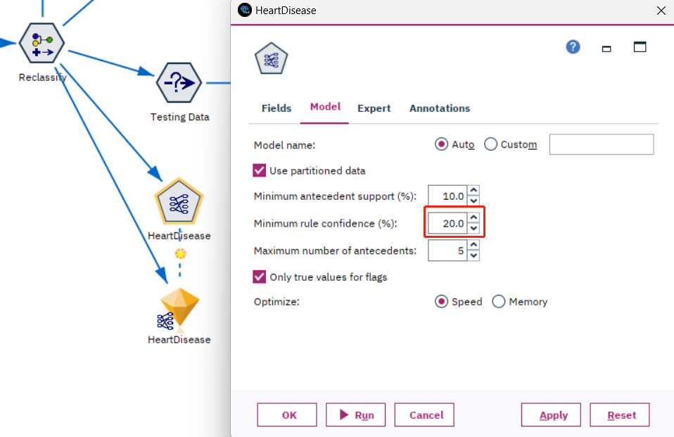

*Figure 68: Parameter setting for Apriori*

**7. Data Mining**

**7.1 Create and justify test designs**

Given my balanced dataset of 49,337 entries, I've decided to employ a 70/30 split for segregating the training and testing sets. Here are my reasons:

1. Adequate Training Data: Using 70% of the data, approximately 34,536 entries, allows me to ensure the model has sufficient data to understand the fundamental patterns and features. More data in machine learning typically allows for better generalization to unseen data.
2. Validating Model's Generalization: Allocating 30% of the data, around 14,801 entries, as a test set lets me gauge the model's performance on unseen instances. This offers a sizable dataset for validation, ensuring the evaluation of the model is robust and dependable.
3. Preventing Overfitting: Over-relying on an extensive amount of data for training can lead the model to become overly complex and begin "memorizing" the training data, which in turn can affect its performance on the test set. A 70/30 split strikes a balance between training demands and the risk of overfitting.
4. Common Practice: The 70/30 split is a typical practice in data science. Experience has shown that it tends to yield solid results for a variety of datasets and tasks.
5. Balanced Data Consideration: As my dataset is balanced, I don't have to worry about class imbalances arising in the training or testing segments, which could potentially skew the model's evaluations. The 70/30 allocation ensures ample representation of both positive and negative cases in both the training and test sets.

In conclusion, given the size and characteristics of my dataset, the 70/30 split emerges as a logical and pragmatic choice, ensuring quality in model training and effective validation.

The graph showing below is the partition setting for my current dataset.

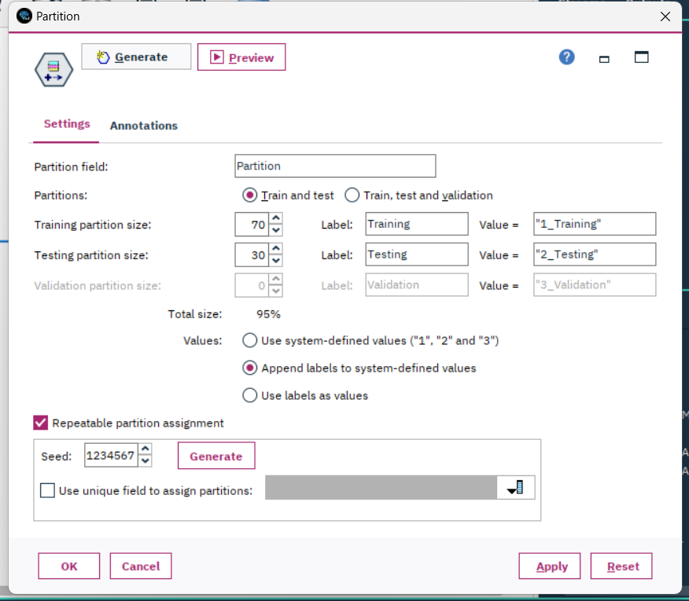

*Figure 69: Partition for Training and Testing*

**7.2 Conduct data mining**

7.2.1 Logistic Regression model conducting

After setting up the testing and training sets, I can utilize the 'select' node to separate the entire dataset into two distinct sets: training and testing. As depicted in the following figure, I used the segregated training data to build the model.

After creating the model, I then connect the test data to it and link the model to the analysis node. This allows me to evaluate the model's performance based on the results from the analysis.



*Figure 70: Stream output for Logistic Regression*

The model results are shown in the figure below.

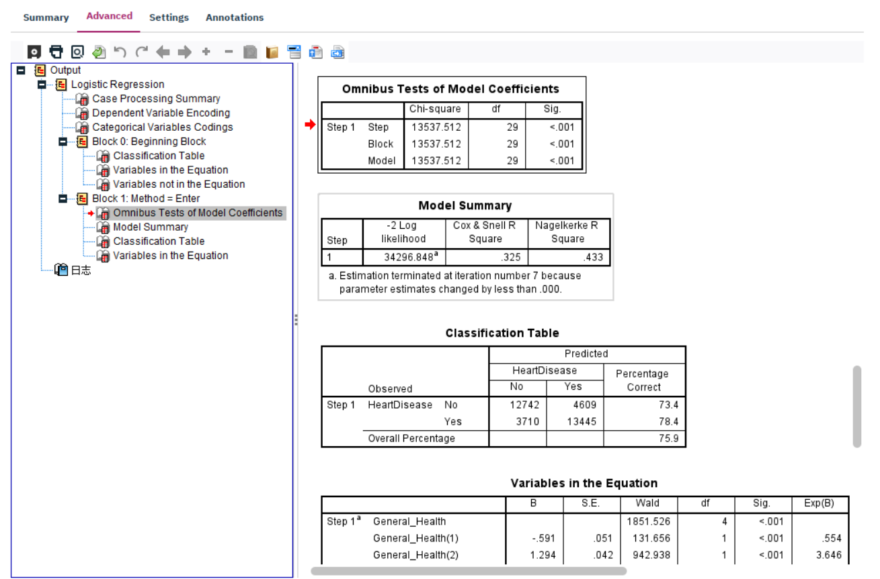

*Figure 71: Logistic Regression model results part 1*

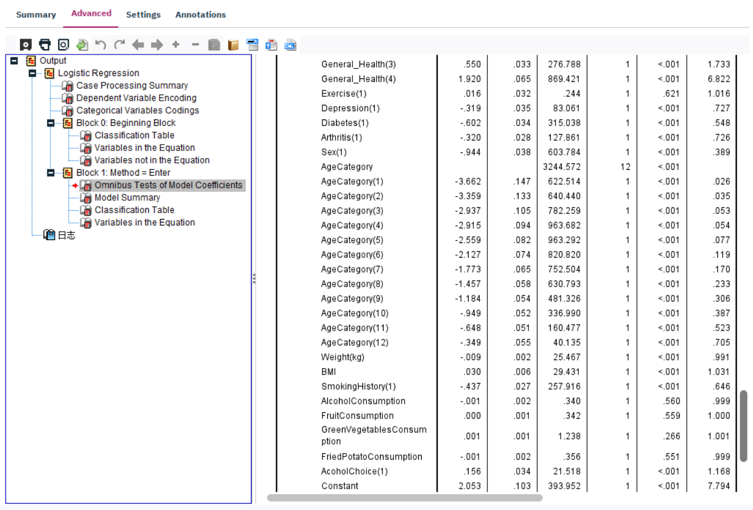

*Figure 72: Logistic Regression model results part 2*

As I mentioned earlier, I connected the generated Logistic Regression model to the analysis node. When setting up this analysis node, my parameter settings are as follows.

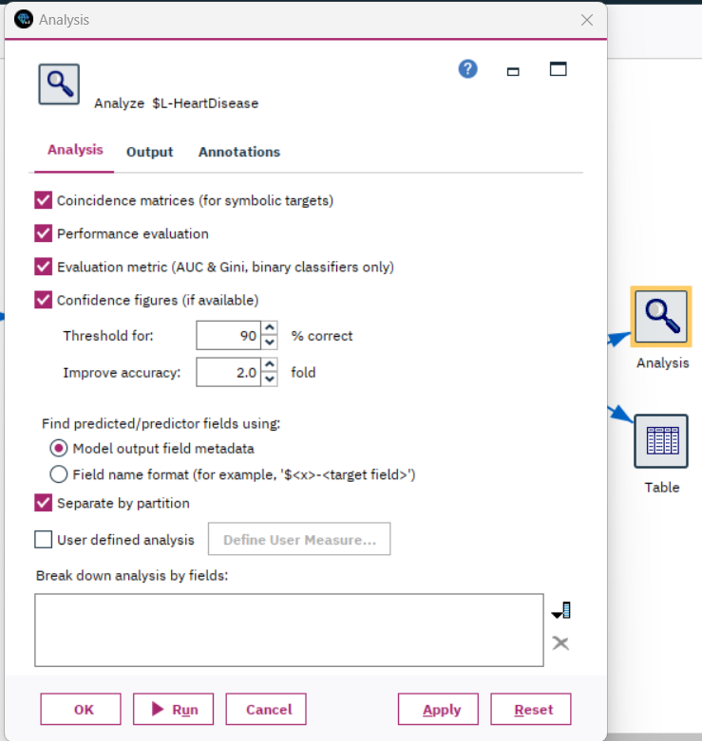

*Figure 73: Parameter settings for analysis of Logistic Regression*

As shown in the image below, when running the analysis node, I used the separated test data. This way, the analysed data is generated based on the test data. This allows for an assessment of how the model, which was built using the training set, performs when applied to the test set.

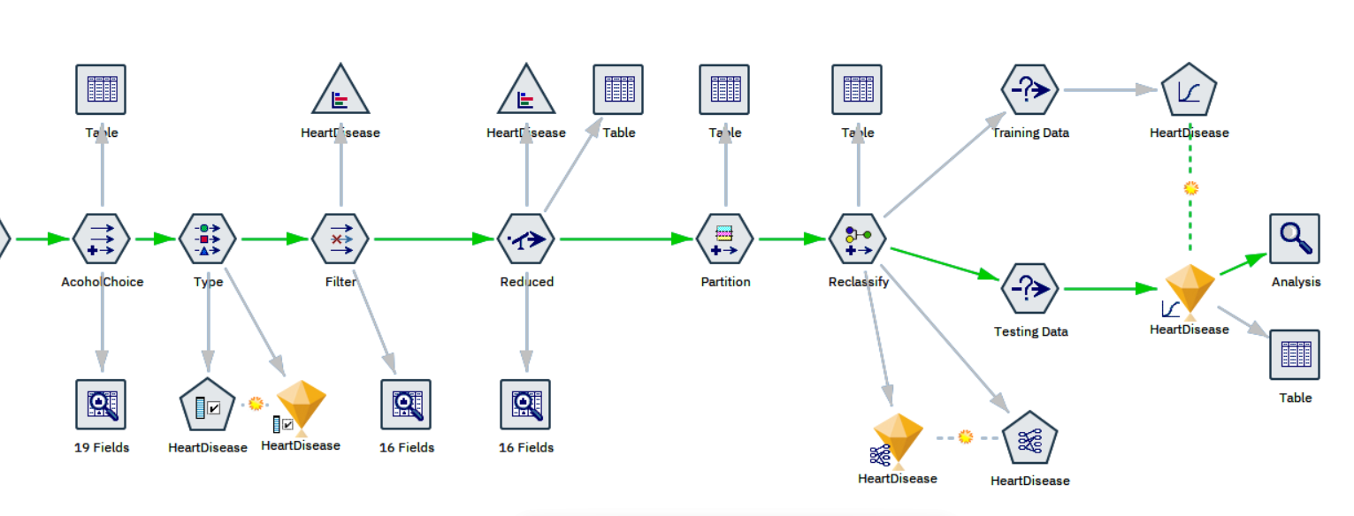

*Figure 74: Conducting stream output on Analysis node*

After running the analysis node, the results obtained are as follows.

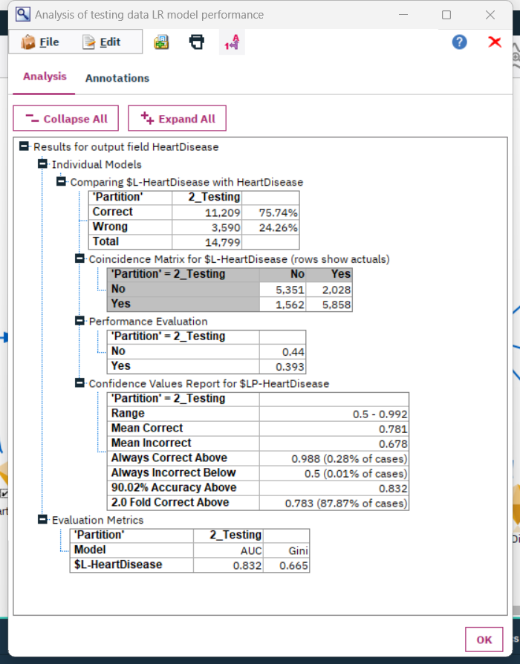

*Figure 75: Analysis results for Logistic Regression*

7.2.2 Apriori model conducting

As the Apriori model falls under the category of association, it doesn't require a split into training and testing sets like the Logistic Regression model. When evaluating the model, it's also necessary to consider the actual scenario. Therefore, when constructing this model, I can simply use the entire dataset before the split, as highlighted in the red box in the following figure.

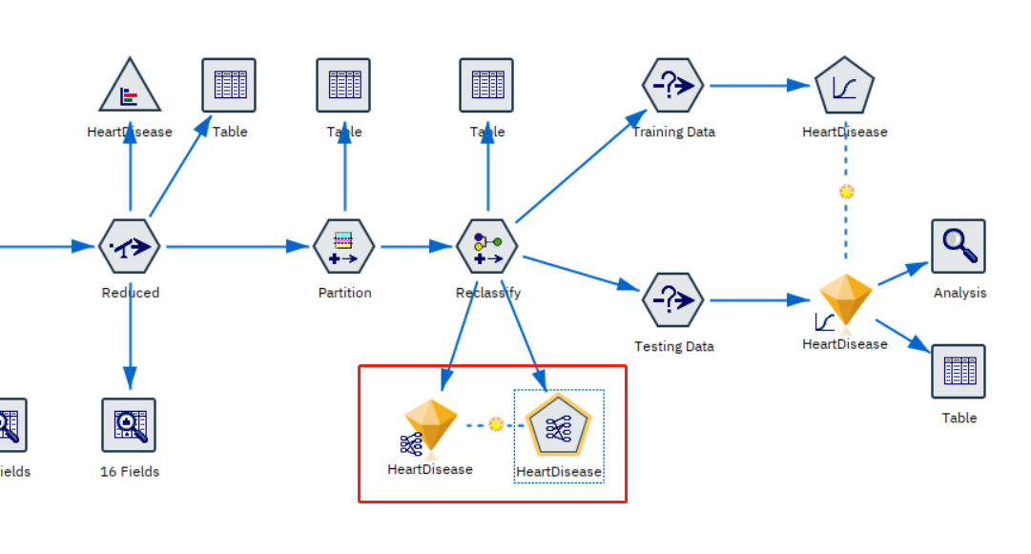

*Figure 76: Stream output for Apriori model*

As illustrated in the following figure, when setting up the Apriori model, I adjusted the minimum rule confidence value to 20% instead of the default 80%. This is because I need to ensure that the model runs successfully. Setting this minimum rule confidence value too high might result in no associations being included, leading to a failed model execution. Therefore, I set this value relatively low to guarantee the model's operation. As for pattern selection, I can sort and filter based on different parameters to meet the requirements of various practical applications.

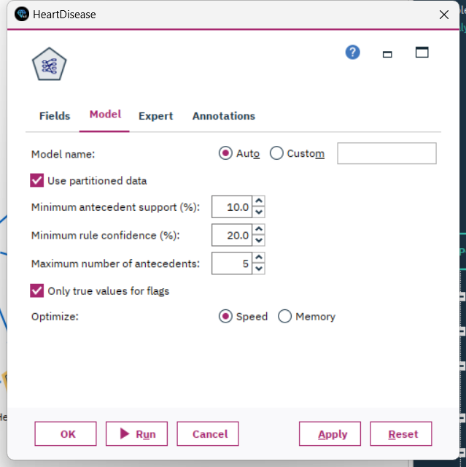

*Figure 77: Parameter settings for Apriori model*

After executing the model, I obtained the results as shown in the following figure.

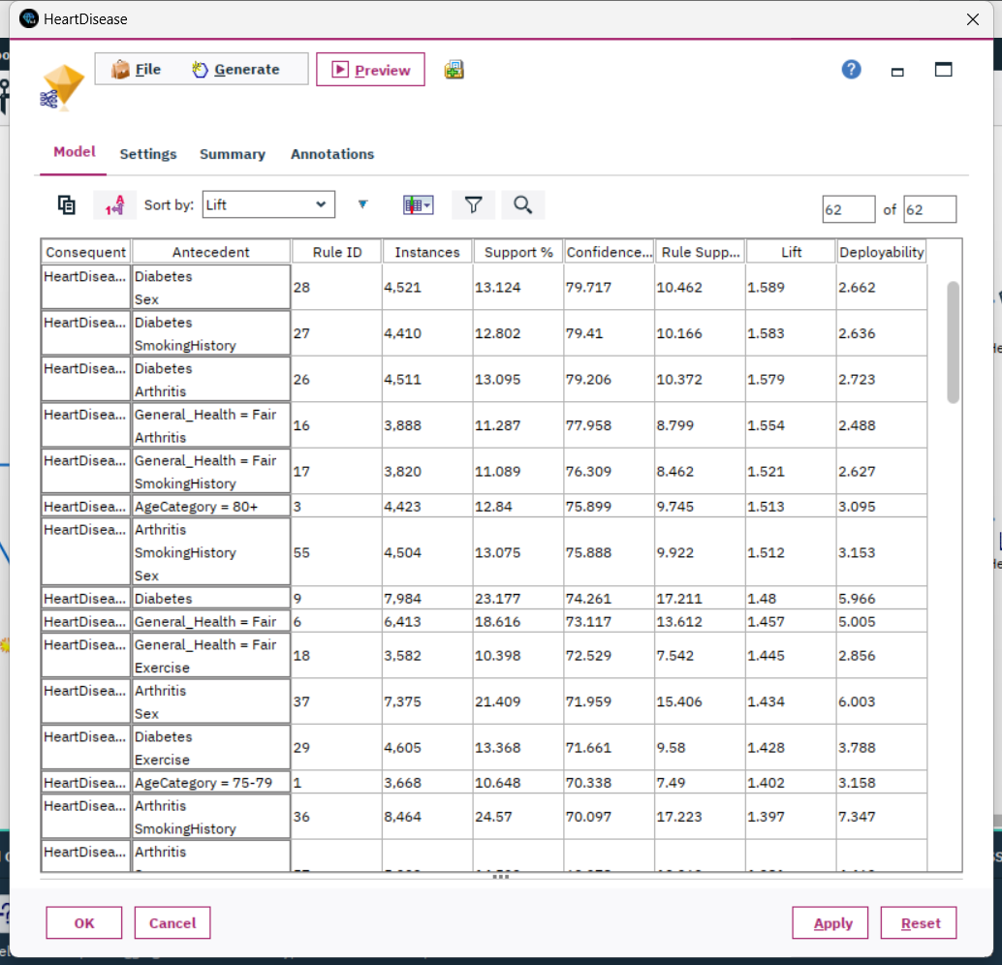

*Figure 78: Apriori model results*

**7.3 Search for patterns and document the model's output.**

In the context of data analysis and machine learning, the term "Pattern" usually refers to a certain regularity, association, or trend in the data, which helps unveil insights and information hidden behind the data. A "Pattern" can be evident or subtle, requiring specific algorithms and tools for identification. In this step, "pattern" can be interpreted as the key information or structure in the model output, providing deeper insights about the data or phenomenon.

1. Patterns in Logistic Regression:
2. Model Coefficients: Each feature's coefficient indicates the strength and direction of its relationship with the target variable. A positive coefficient means that as the feature increases, the log-odds of the target variable also increase, while a negative coefficient suggests the opposite. This offers me insights into which features influence the target variable the most.
3. Odds Ratios: Odds ratios further elaborate on the relationship between each feature and the target variable. Odds ratios greater than 1 suggest a positive correlation between the feature and the target variable, while those less than 1 indicate a negative correlation. This assists in understanding how a feature impacts the odds of the output.
4. p-values: The p-value informs me about the statistical significance of each feature. A small p-value implies that the relationship between the feature and the target variable is unlikely to be by chance, instilling greater confidence when considering it for decision-making.

Pattern 1:

In light of the information provided above, I determined the statistical significance of specific variables in the model based on their p-values. When P < 0.05, it is considered statistically significant. Therefore, in the following figure, I've highlighted the parameters that are not statistically significant. They are Exercise, AlcoholConsumption, FruitConsumption, GreenVegetableConsumption, and FriedPotatoConsumption. This suggests that these variables do not have a significant predictive ability concerning the classification decision of having a heart disease or not.

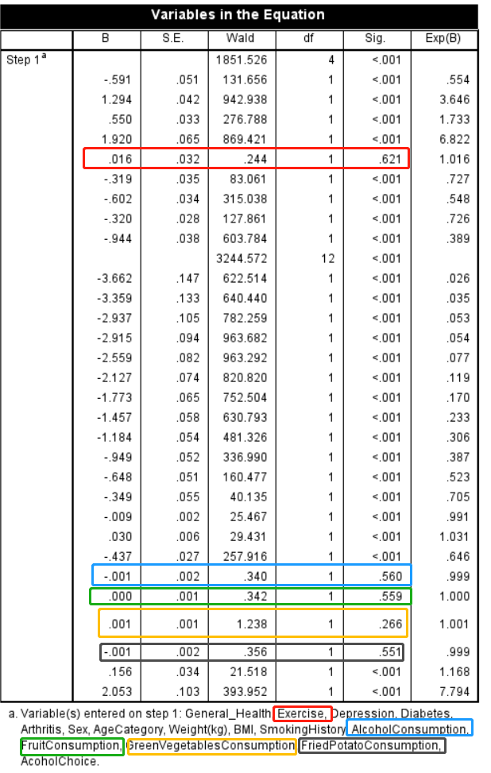

*Figure 79: Variables in Logistic Regression model equation*

Pattern 2:

Based on the Model Coefficients and Odds Ratios, I can determine the strength and direction of the relationship between a particular feature and the target variable. Each subclass of the age category is negatively correlated with the target variable. In addition, as highlighted in the red circles in the figure below, the majority of the high-magnitude coefficients are concentrated in certain age categories. Furthermore, they all show a negative relationship. This implies that as this feature increases, the log odds of the target variable decrease.

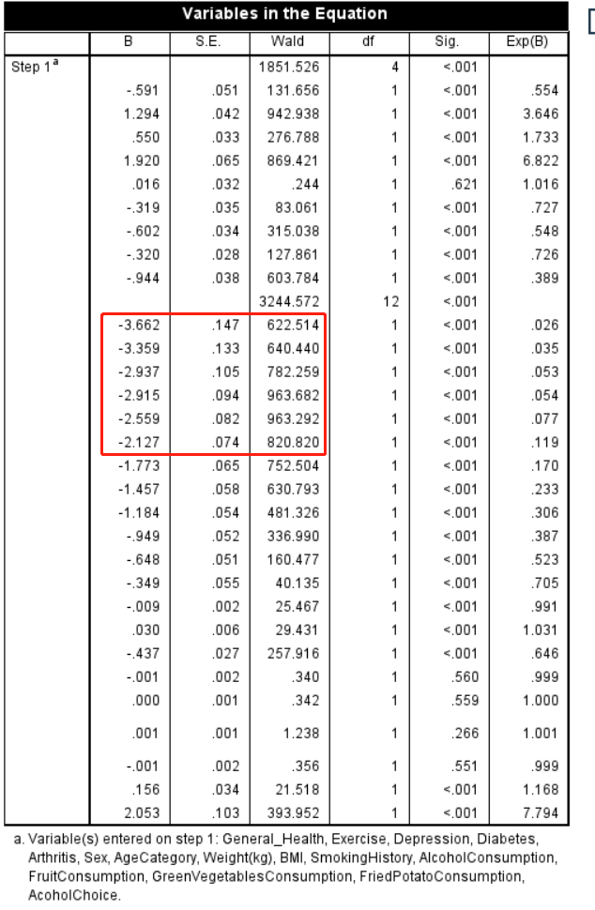

*Figure 80: Variables in Logistic Regression model equation*

1. Patterns in the Apriori Algorithm:
2. Frequent Itemsets: These are data items that often appear together. Knowing which items frequently co-occur helps me understand the inherent structure and associations in the data.
3. Association Rules and Their Metrics:
4. Support: This metric tells me the frequency with which the item combination in the rule appears. High support indicates that these items often appear together.
5. Confidence: This indicates how sure I am of the conclusion occurring when I see the premise of the rule. It gives me a measure of the accuracy of the rule.
6. Lift: It describes whether the premise and conclusion are genuinely related or if they co-occur by chance. A lift greater than 1 suggests that they do have some sort of relationship and aren't just random.

Pattern 3:

The figure below displays the results of the Apriori model. As I've highlighted with the red box, I used lift as the standard for descending order sorting. The top three results are combinations of diabetes with other diseases or features. Additionally, diabetes on its own ranks eighth. Hence, we can infer that there is a significant association between diabetes and the onset of heart disease. This association is especially pronounced when the patient is male, has a history of smoking, or has a comorbid condition of arthritis.

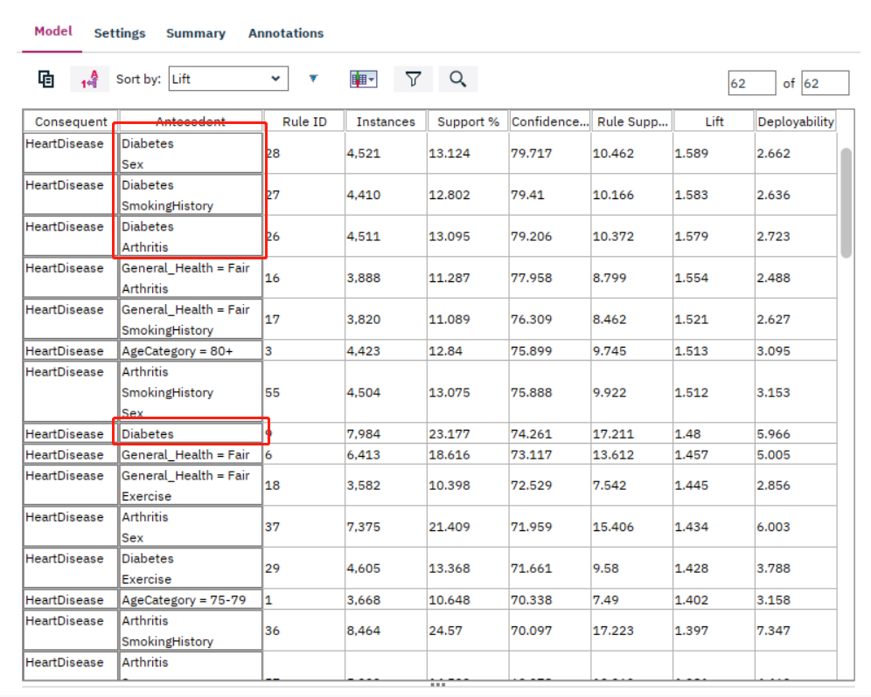

*Figure 81: Results of Apriori model*

Pattern 4:

From the figure below, I can observe that having a smoking history and being diagnosed with arthritis are closely related to the incidence of heart disease. The chart displays the top 15 results when sorted in descending order based on lift. Among these results, a smoking history appears 4 times, with 2 occurrences in the top five. Arthritis appears 6 times, with two of those being in the top five as well. Additionally, the combination of both factors appears twice in the top 15. Therefore, I can conclude that having a smoking history and being diagnosed with arthritis are both strongly associated with the incidence of heart disease.

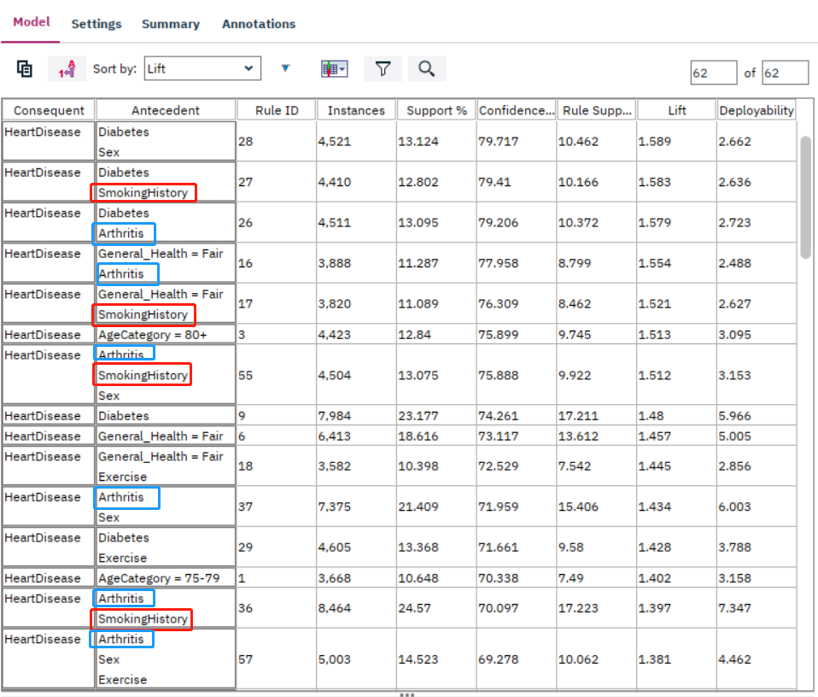

*Figure 82: Results of Apriori model*

Additionally, as a supplement to the content of pattern2, I can infer from the Apriori model that older individuals have a higher likelihood of developing heart disease. As highlighted in the red section of the figure below, individuals aged over 80 rank 6th as the primary non-combined correlating factor in relation to heart disease occurrence. This is the highest ranking for any single-factor characteristic. The next age-based single factor is the 75-79 age bracket, which ranks 13th. Both of these single-factor features rank within the top 15, and both have a confidence level exceeding 70%. This solidly suggests that individuals aged 75 and above have a significantly increased risk of developing heart disease.

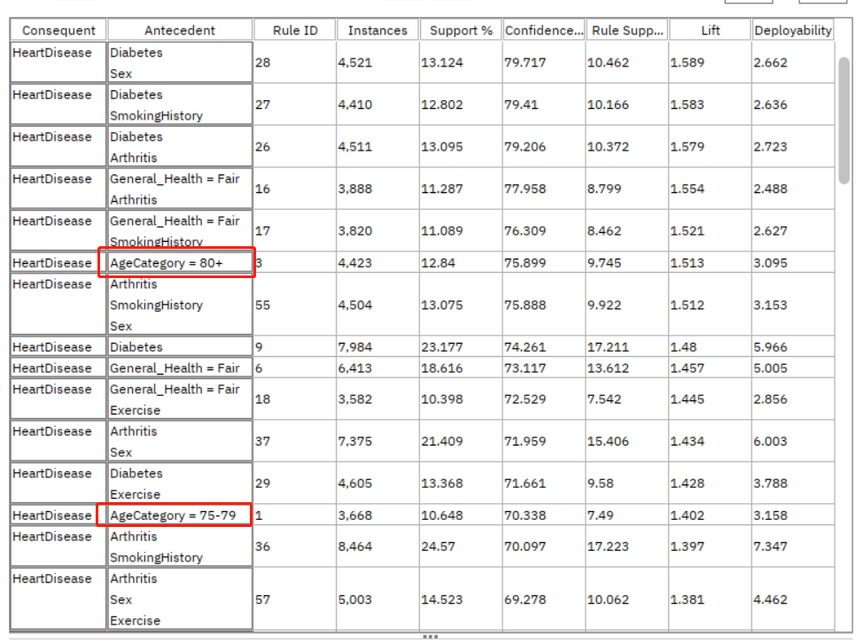

*Figure 83: Results of Apriori model*

**8. Interpretation**

**8.1 Study and discuss the mined patterns**

Pattern 1: As shown in the figure below, in the variable not in the equation, the score of various consumption features is mostly small. While some lifestyle factors such as alcohol consumption, fruit consumption, green vegetable consumption, and fried potato consumption appear to be statistically insignificant in relation to heart disease in my model, it's critical not to dismiss their importance outright. There may be other external or latent variables identified in different studies that influence these relationships. Hence, public health advisories might need to emphasize more on factors that have shown significant associations with heart disease in this research, rather than overemphasizing those that haven't.

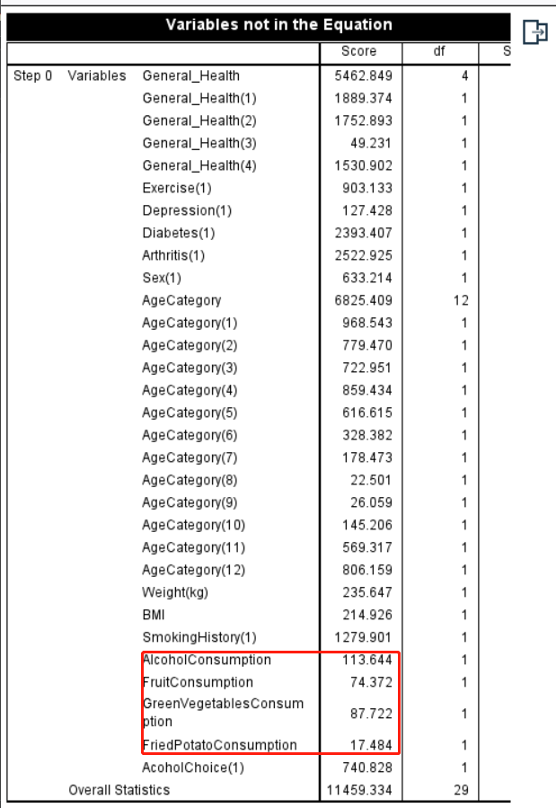*Figure 84: Variable not in the equation in Logistic Regression*

Pattern 2: The data strongly suggests a negative correlation between age and the onset of heart disease. As the figure shown below, given that my data uses the age bracket of 80 and above as the reference point set at zero, this negative correlation indicates that younger age groups face a lower risk of heart disease relative to those aged 80 and above. This aligns with common knowledge: younger individuals generally possess stronger physiological functions and recovery abilities. As age increases, so does the risk of multiple chronic diseases. Therefore, strategies and recommendations to prevent heart disease might need tailored adjustments for different age groups. For younger populations, emphasizing healthy lifestyles and early prevention could be key. However, when considering older patients, more aggressive strategies might be necessary to assess and manage the risk of heart disease, accounting for age-related health factors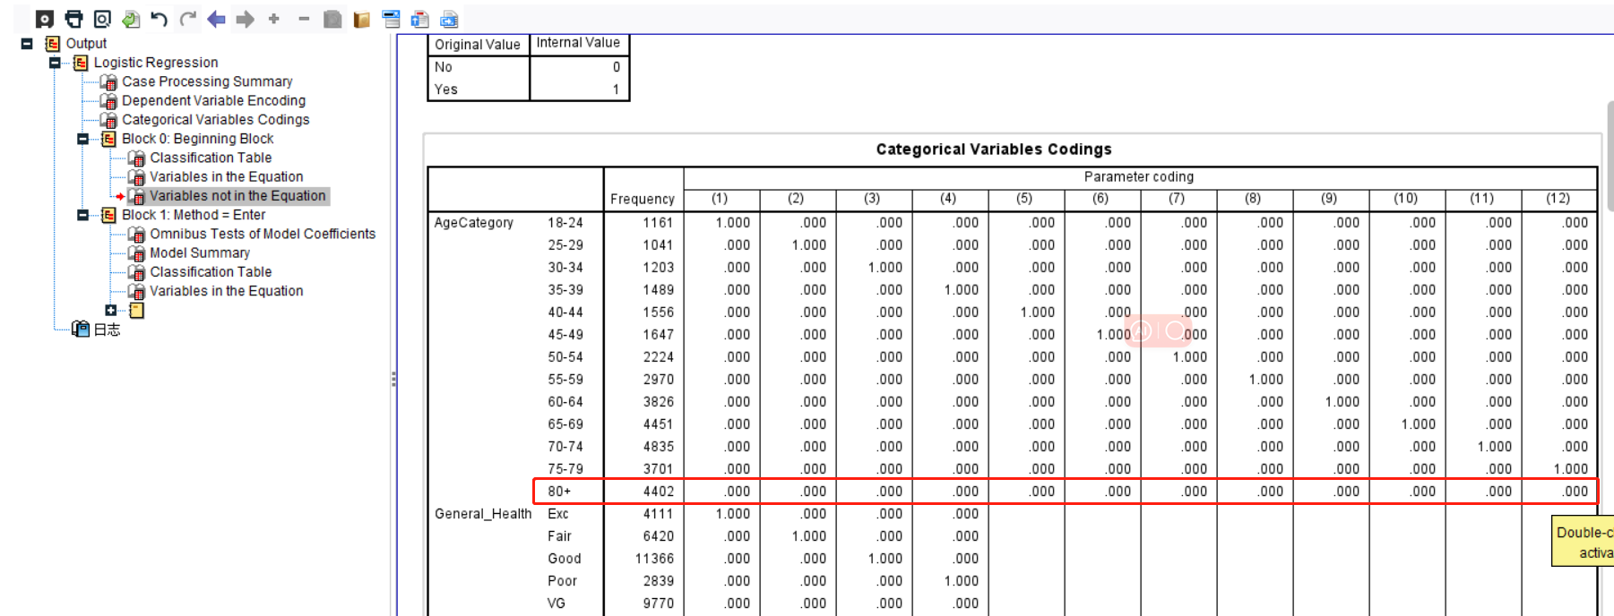

*Figure 85: Categorical Variable codings*

Pattern 3: The Apriori model reveals a significant association between diabetes and heart disease, particularly among males, smokers, and arthritis patients. Not only in the Apriori model, but also in the Logistic Regression model, the score of diabetes is very high. As shown in the figure below, a high score means that variables contribute more to the model, that is, the prevalence of diabetes plays a very important role in predicting whether the person suffers from heart disease. This could be due to vascular inflammation caused by diabetes or other impacts diabetes has on vascular health. Both smoking and arthritis might be indicators of inflammatory responses, potentially affecting cardiac health. Thus, for populations at high risk, strategies for preventing and treating heart disease should pay special attention to these diabetes-related risk factors.

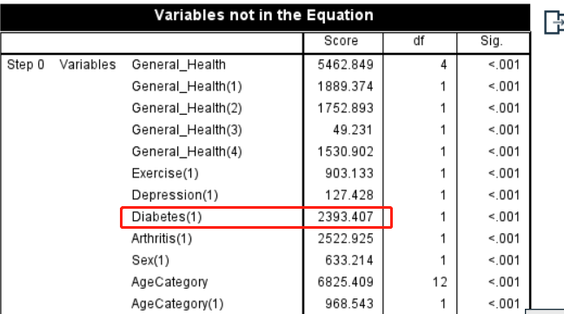

*Figure 86: Variable not in the equation in Logistic Regression*

Pattern 4: The association of a history of smoking and arthritis with heart disease underscores the significance of lifestyle habits and inflammatory status in the onset of cardiac conditions. As highlighted by the red box in the figure below, in the "Variable not in the equation" section of the Logistic Regression, both the score for smoking history and the incidence of Arthritis are notably high.Smoking and arthritis might trigger inflammatory responses in the body, in turn elevating the risk of heart disease. Additionally, smoking might be associated with other risk factors for heart disease, such as hypertension and high cholesterol. So, in addition to controlling diabetes and other known risk factors, it's essential to focus on inflammation and related diseases when looking at heart disease prevention.

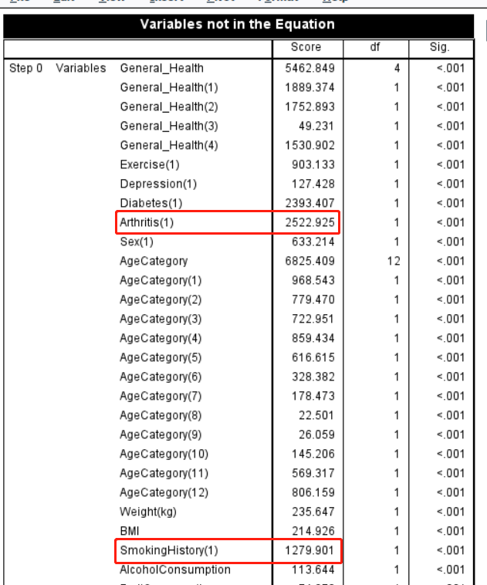

*Figure 87: Variable not in the equation in Logistic Regression*

**8.2 Visualize the data, results, models, and patterns**

Since I used two different models, visualization needs to be conducted separately for each.

1. Logistic Regression Model

1. Coefficient visualization of Logistic Regression Model

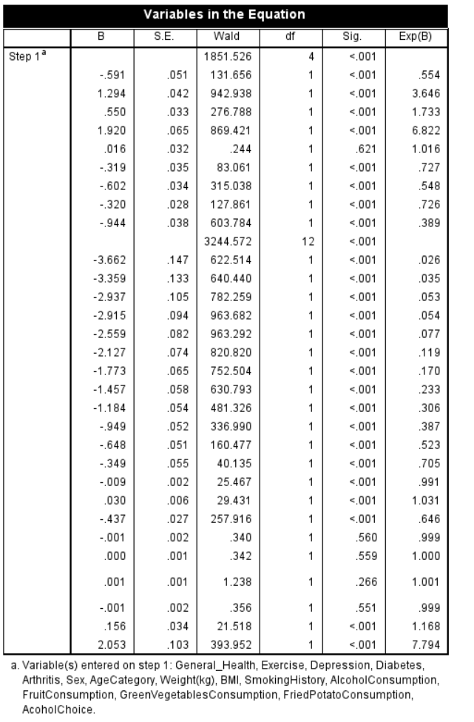

*Figure 88: Coefficient visualization of Logistic Regression Model*

1. Analysis data of Logistic Regression Model

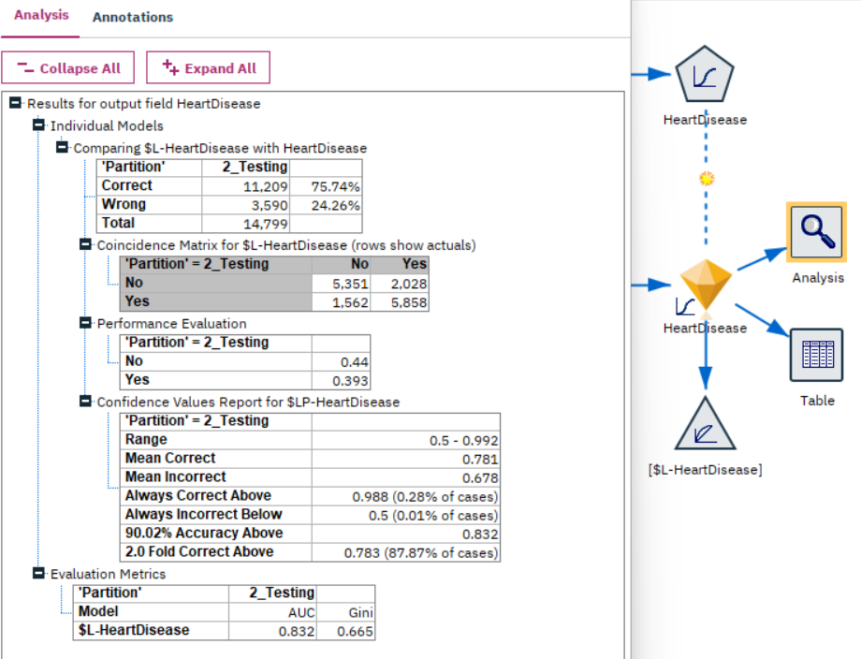

*Figure 89: Analysis data of Logistic Regression Model*

1. ROC curve of Logistic Regression Model

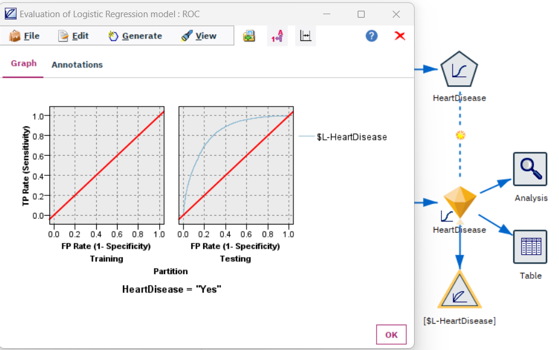

*Figure 90: ROC curve of Logistic Regression Model*

2. Apriori Model

1. Results of Apriori Model

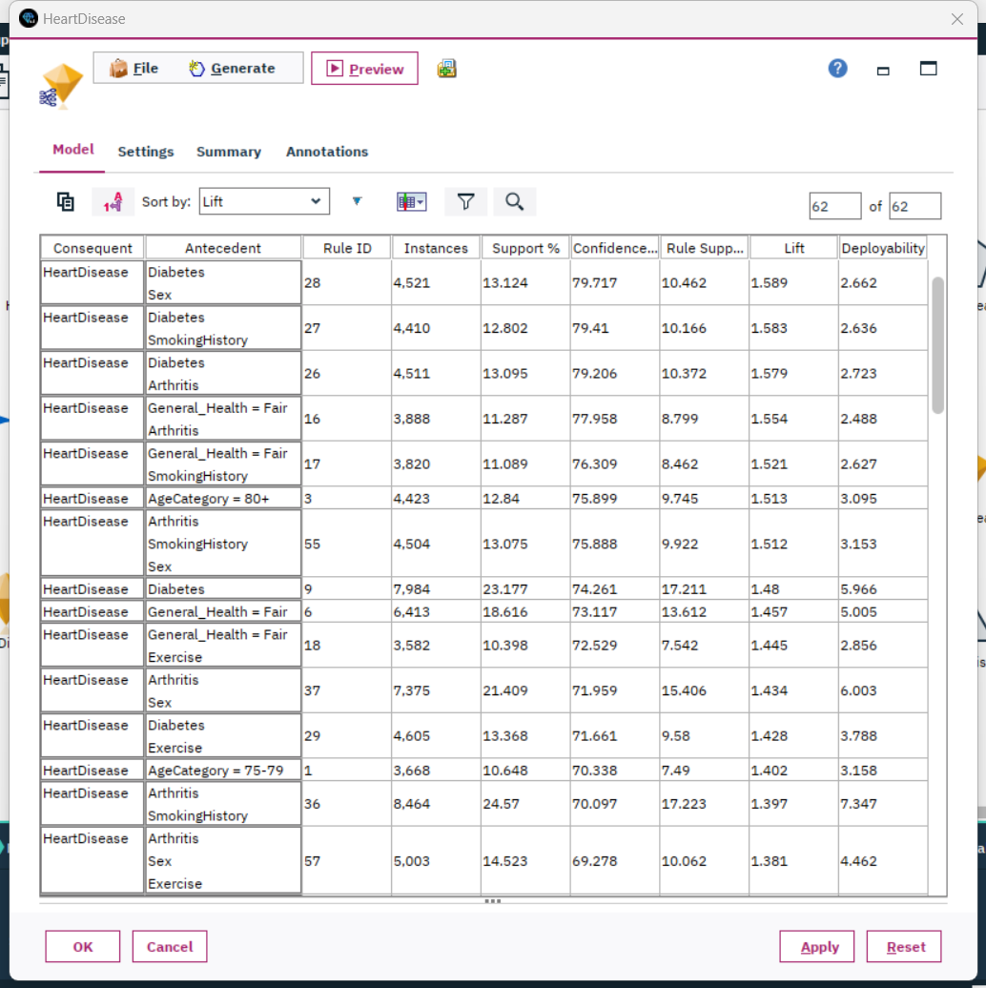

*Figure 91: Results of Apriori Model*

1. Web graph to target field

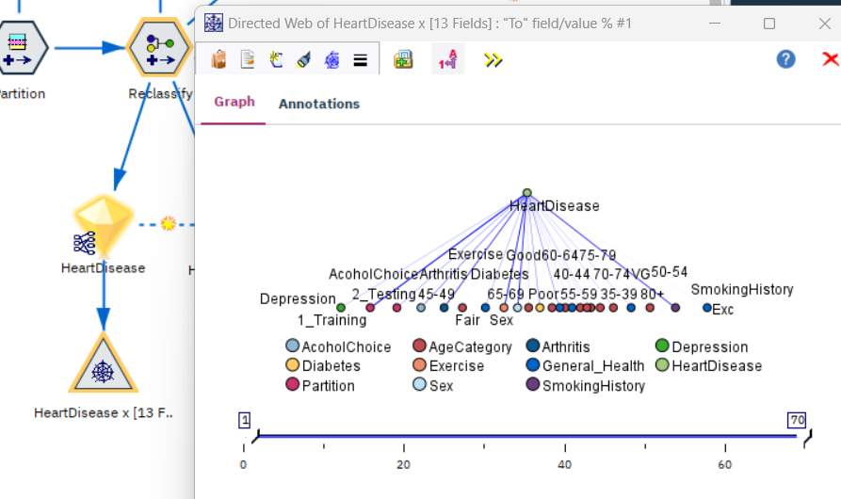

*Figure 92: Web graph to target field*

**8.3 Interpret the results, models, and patterns**

In my previous analysis, I utilized Logistic Regression and the Apriori model to delve deeply into the relationship between lifestyle habits, age, and other health factors with heart disease. Just like what I showed in the previous step with the visualization tool.

Initially, while certain lifestyle habits such as alcohol consumption, and food choices didn't have a significant effect in the model, this doesn't imply they're entirely unrelated to heart disease. There might be other external or hidden factors at play. This also reminds us that in public health promotion, emphasis should be placed more on factors that have been proven to have a significant association with heart disease.

Next, the data on age revealed an intriguing pattern. Younger individuals face a lower risk of heart disease compared to those aged 80 and above, aligning with our understanding of the physiological capabilities and recuperative powers of the younger population. However, as age increases, so does the risk of various chronic diseases. This provides invaluable insights for healthcare providers, indicating that preventive strategies might need adjustments based on age groups. For instance, the focus for the young might be on establishing healthy habits, while for the elderly, other age-related health factors might need more attention.

Moving on to the association with diabetes, especially among males, smokers, and arthritis patients, a significant link between diabetes and heart disease was identified. This might be due to vascular inflammation caused by diabetes or other impacts on vascular health. Moreover, both smoking and arthritis are related to inflammation, further underscoring the pivotal role of lifestyle habits and inflammatory states in the onset of heart disease. Thus, for high-risk groups, attention should be paid particularly to risk factors associated with diabetes.

In conclusion, although we couldn't explore all potential variables and associations in this study, these findings offer valuable insights for medical and health professionals regarding heart disease risks and possible prevention strategies. Future research might delve deeper into factors not considered here to enrich our understanding.

**8.4 Assess and evaluate results, models, and patterns**

1. Assess for models

After evaluating my logistic regression model by analysis node, I found it demonstrates quite commendable performance. Firstly, the model's accuracy rate reached 75.74%, implying that nearly three-quarters of the predictions were correct across all test data. This instilled in me a substantial amount of confidence, leading me to believe that the model could maintain relative accuracy when dealing with unknown data.

However, what I place more emphasis on is the model's AUC value, as it offers a more comprehensive view of the model's ability to distinguish between positive and negative classes. My model's AUC stands at 0.832, which is typically considered "very good" in practical applications. An AUC value nearing 1 indicates that the model performs exceptionally well in differentiating between positive and negative categories, whereas a 0.5 AUC suggests the model lacks discriminative power, equivalent to a random guess. Given that 0.832 is significantly greater than 0.5 and approaches 1, it strongly signifies the model's excellent performance in the classification task.

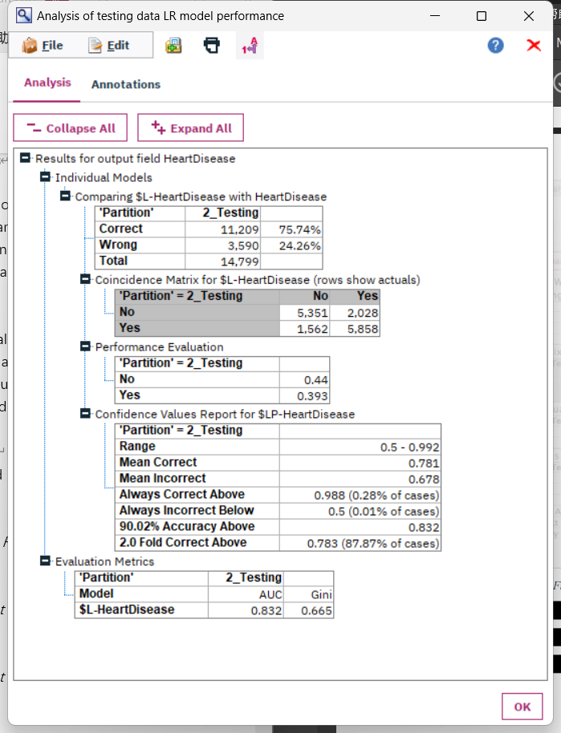

*Figure 93: Analysis node for Logistic Regression*

After evaluating the results of my Apriori model,as the graph shown below, I focused on three key metrics: Support, Confidence, and Lift. Here's my analysis of the model's performance based on these metrics:

a. Support:

The highest support I observed was 71.064% for the association between Exercise and HeartDisease. This implies that about 71% of the records in my dataset simultaneously exhibit both exercise habits and heart disease. This strong association suggests that the combination of heart disease and exercise is frequent in this dataset.

Furthermore, many rules showed a support exceeding 10%. This indicates that these associations are not rare occurrences in the dataset.

b. Confidence:

Confidence displays the probability of the consequent occurring, given the presence of the antecedent.

The highest confidence value I found was 79.717% for the association between Diabetes, a specific Sex, and HeartDisease. This means that nearly 80% of individuals with diabetes and of a particular gender are at risk of heart disease.

I also noticed a substantial number of rules with confidence levels above 50%. This indicates a high level of reliability for these associations.

c. Lift:

A lift value greater than 1 indicates that the probability of the consequent occurring, given the antecedent, exceeds the probability of the consequent occurring on its own.

The maximum lift value in my results was 1.589 for the association between Diabetes, Sex, and HeartDisease, strongly suggesting a positive correlation between diabetes, a particular gender, and heart disease.

However, there were some rules with lift values below 1, such as the rule connecting General_Health = VG, AlcoholChoice, Exercise, and HeartDisease with a lift of 0.611. This could imply a negative correlation or a lack of significant association between these factors and heart disease.

My Apriori model revealed several factors and combinations that have a strong association with heart disease. Particularly, the rules with high confidence and lift values offer crucial insights. However, some associations exhibited weaker performance, which might be less significant in real-world applications. Therefore, I believe that I should focus on rules with high Support, Confidence, and Lift in practical scenarios, while approaching those with weaker metrics more cautiously.

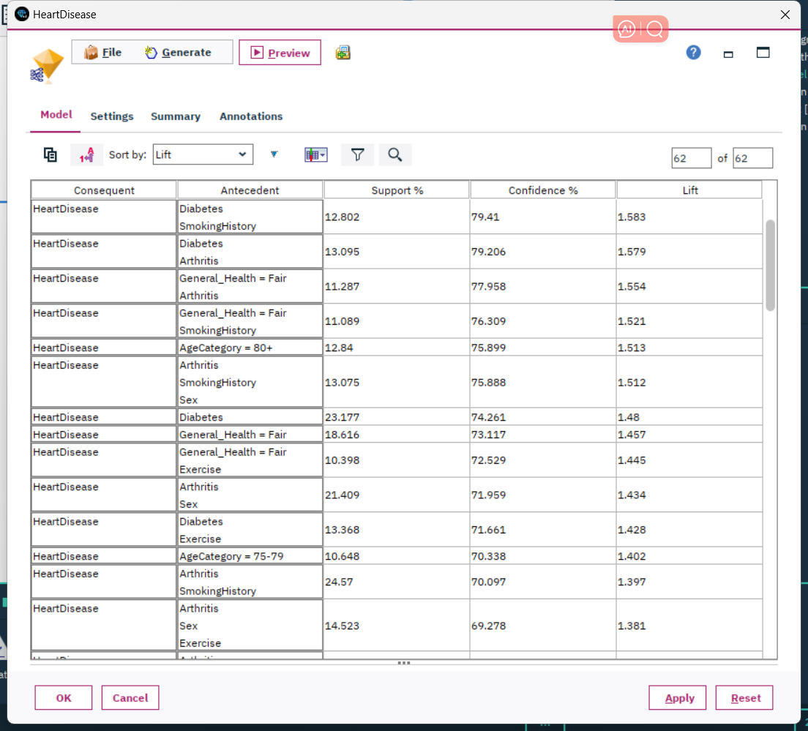

*Figure 94: Results of Apriori model*

2. Assess for decision making

In the intricate landscape of heart disease risk factors, I've identified distinct patterns through the Apriori model that shed light on potential prevention strategies. Based on these discerned patterns, I present an assessment to guide decision-making in managing and mitigating heart disease risk.

Pattern 1: Importance of Lifestyle Factors.

Insight: Even though certain lifestyle factors don't exhibit a significant correlation with heart disease in this model, external studies may have established links.

Decision Recommendation: Rather than discarding the role of the stated lifestyle factors, public health campaigns should present a holistic view of heart health. They should strike a balance by emphasizing factors that showed significant associations in your study, while also acknowledging the potential roles of exercise, diet, and alcohol consumption as highlighted in external research. A nuanced approach, incorporating findings from multiple studies, would be most beneficial for public awareness and heart disease prevention.

Pattern 2: Age as a Negative Correlation.

Insight: The younger age groups exhibit a reduced risk of heart disease compared to individuals 80 and above.

Decision Recommendation: Heart health campaigns should be tailored based on age demographics. For younger individuals, the focus can be on fostering healthy habits to ensure long-term cardiac health. For the older population, aggressive monitoring and interventions could be pivotal, considering their increased vulnerability to heart disease. Regular screenings, medication, and specialist consultations should be more frequent for this age bracket.

Pattern 3: Diabetes' Strong Association with Heart Disease.

Insight: There's a pronounced link between diabetes and heart disease, especially among males, smokers, and those with arthritis.

Decision Recommendation: Medical practitioners should prioritize diabetic patients, especially those with the associated risk factors (males, smokers, arthritis patients), for regular cardiac health check-ups. These groups may benefit from specialized care programs focusing on early detection and management of heart conditions. Further, diabetes management campaigns should highlight the potential cardiac risks associated with the condition, emphasizing the importance of vigilant diabetes control.

Pattern 4: Smoking, Arthritis, and Heart Disease Association.

Insight: Smoking and arthritis, which might induce inflammatory responses, are significantly associated with heart disease.

Decision Recommendation: Public health programs should stress the dangers of smoking, not just from a lung health perspective but also in the context of cardiac health. Patients with arthritis should be made aware of their elevated heart disease risk and should be advised to attend regular heart screenings. Health practitioners should consider proactive interventions, such as anti-inflammatory treatments, in their strategy for heart disease prevention among arthritis patients.

Overall Decision Implications:

The patterns deduced from the Apriori model can be of immense value in shaping heart health strategies, public awareness campaigns, and medical interventions. By identifying and acting upon these specific risk factors and associations, policymakers and medical professionals can enact targeted approaches that address the unique needs of different risk groups, potentially leading to improved heart health outcomes in the broader population.

**8.5 Iterate prior steps (1 – 7) as required**

1. Adjustment in Data Balancing Strategy:

Initially, I utilized the reduce method, which meant downsizing data to achieve a balance between positive and negative samples. This approach, while effective, could lead to the potential loss of valuable information, especially when working with limited data. Recognizing this limitation, I shifted to the boost method. Boosting aims to enhance the balance by increasing the representation of the minority class, ensuring not only that the imbalance issue is addressed but also that I harness the full potential of the available data without unnecessary losses.

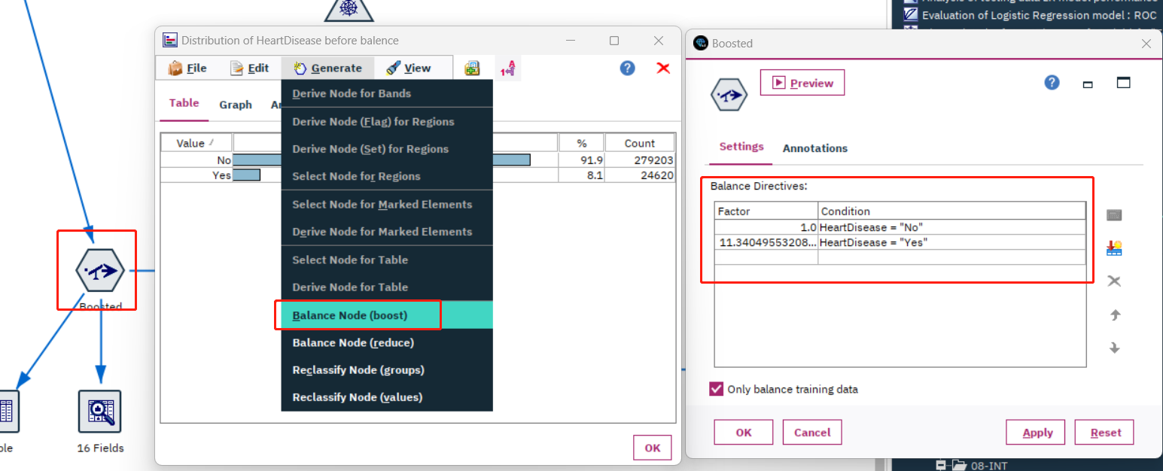

*Figure 95: Boosting dataset to project data*

As illustrated in the following figure, we compared the accuracy of the Logistic Regression model after balancing the data using both the reduce and boost methods. Employing the boost method to balance the data resulted in a slight improvement in the model's accuracy and AUC.

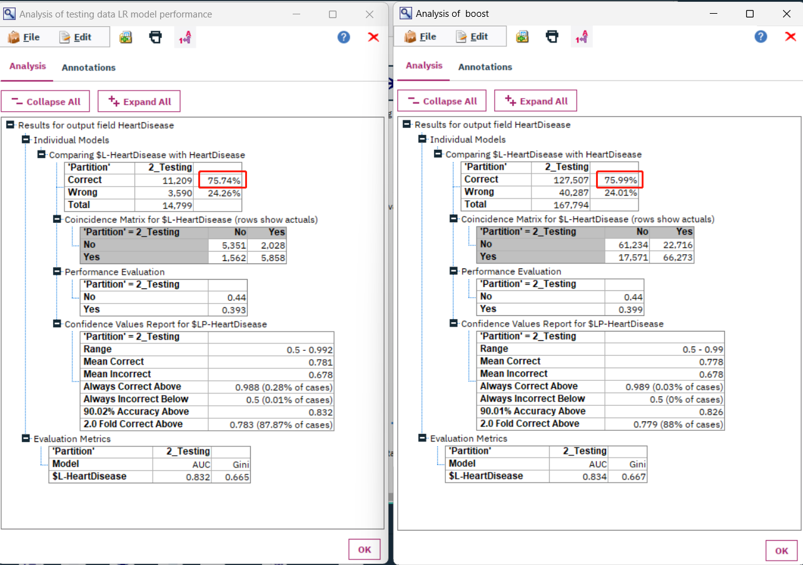

*Figure 96: Comparison of 2 models in analysis node*

2. partition ratio Modification:

My preliminary dataset split was at a 70/30 ratio, a commonly accepted split that usually delivers reliable results, ensuring ample data for training while retaining a robust set for performance evaluation. However, considering the specific nature and volume of my dataset, I believed that more training data might yield a more stable model. Consequently, I adjusted the ratio to 80/20. This would allow the model to learn from an enriched data set, potentially boosting its generalization capabilities.

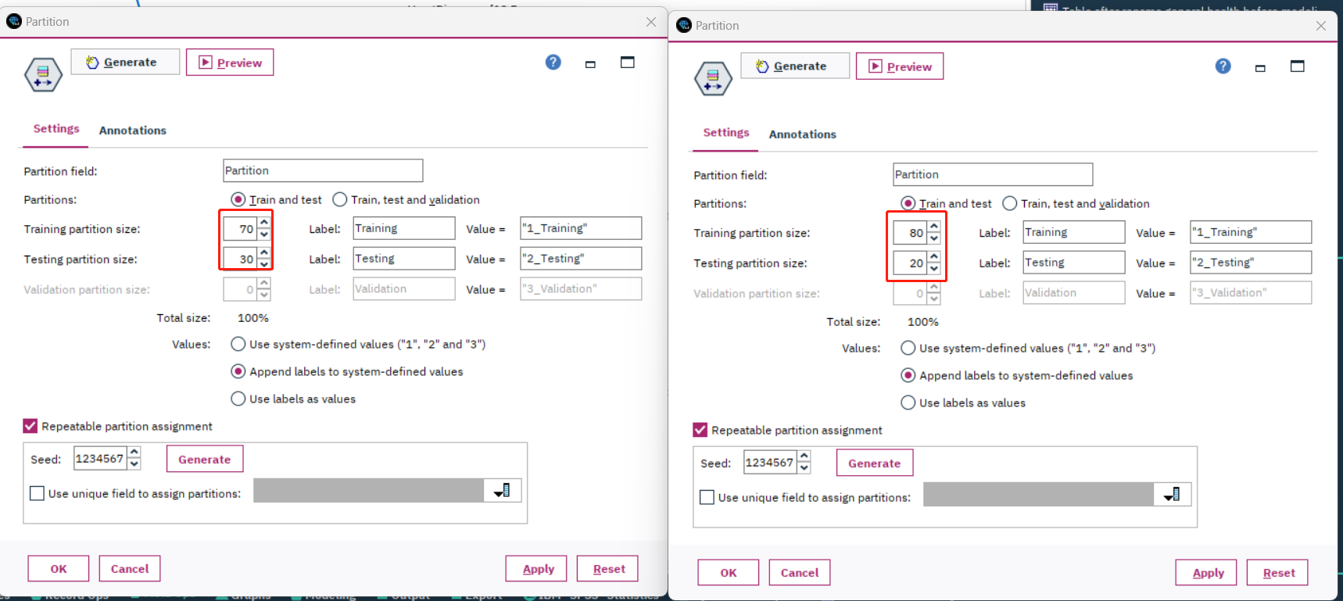

*Figure 97: Changing partition ratio to 80/20 from 70/30*

As depicted in the graph below, after adjusting the partition, Logistic Regression model showed a subtle increase in accuracy and AUC.

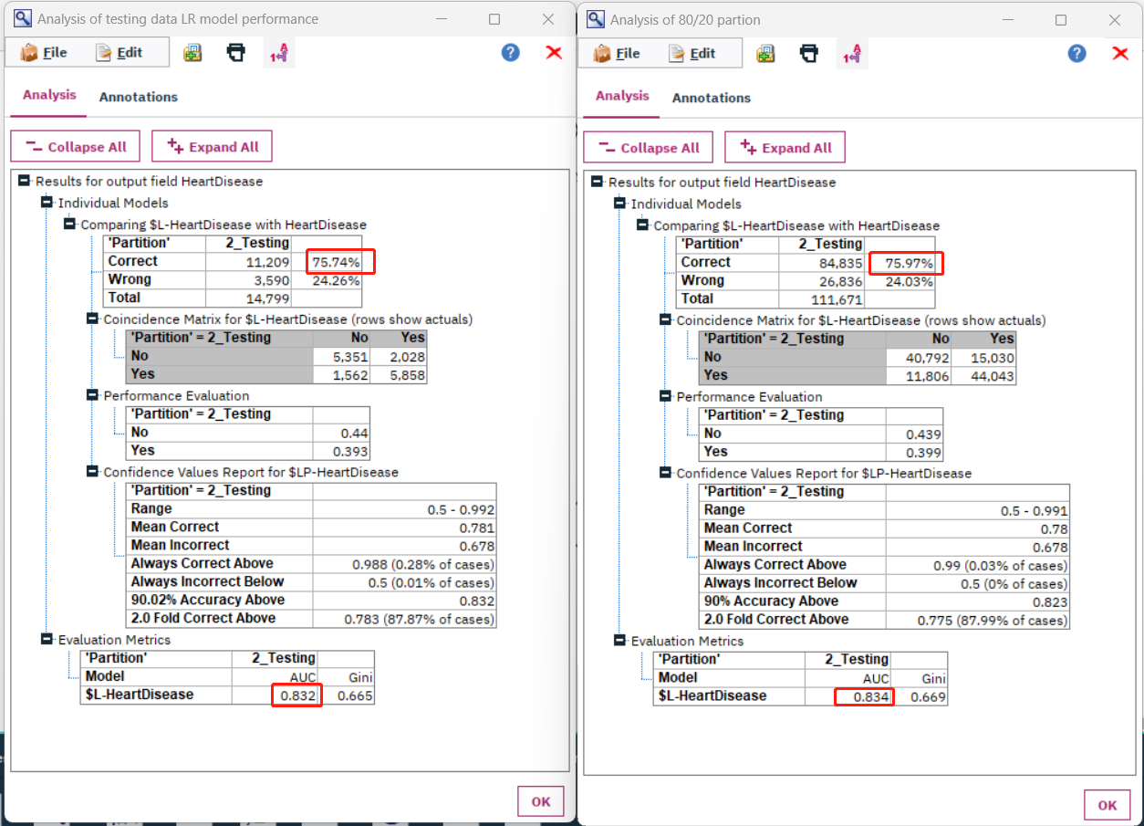

*Figure 98: Comparison of 2 models in analysis node*

3. Change in the Logistic Regression Parameter Selection Method:

I had initially chosen the Enter method, where all variables are incorporated into the model simultaneously. However, this could inadvertently introduce irrelevant or superfluous variables, potentially muddying the model's interpretability and accuracy. Seeking a more streamlined, interpretable, and efficient model, I transitioned to the forward stepwise method. This approach begins with a blank slate, incrementally adding variables that provide significant contributions to the model, ensuring that only truly impactful predictors are retained.

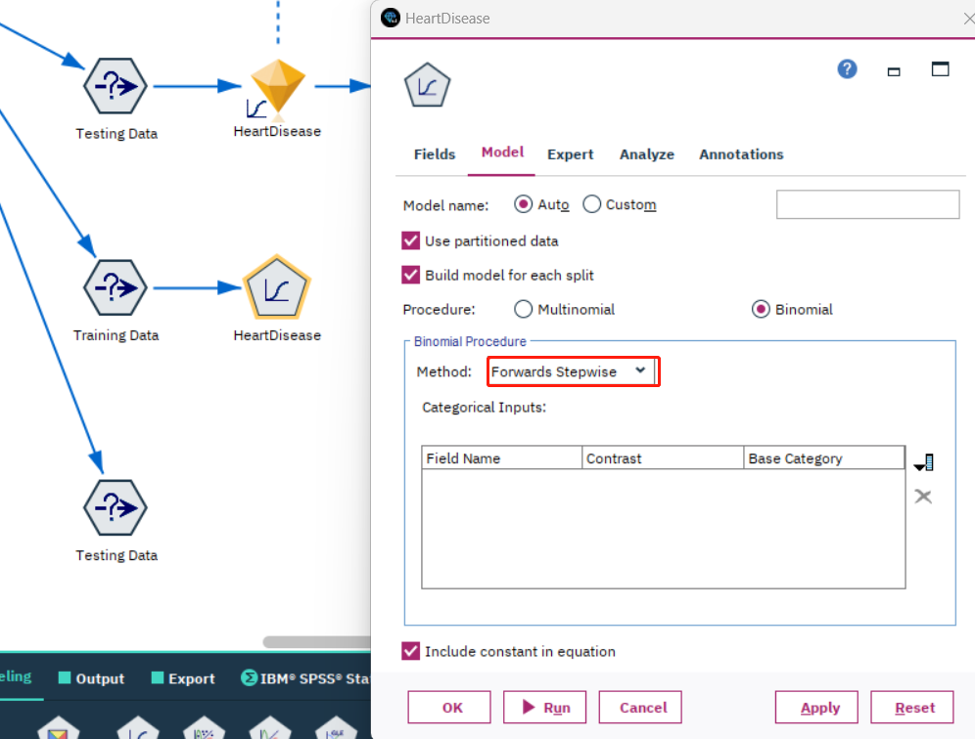

*Figure 99: Changing parameter of Logistic Regression model*

According to the graph below, by changing the method from "enter" to "forward stepwise", the model experienced a subtle improvement in accuracy and AUC.

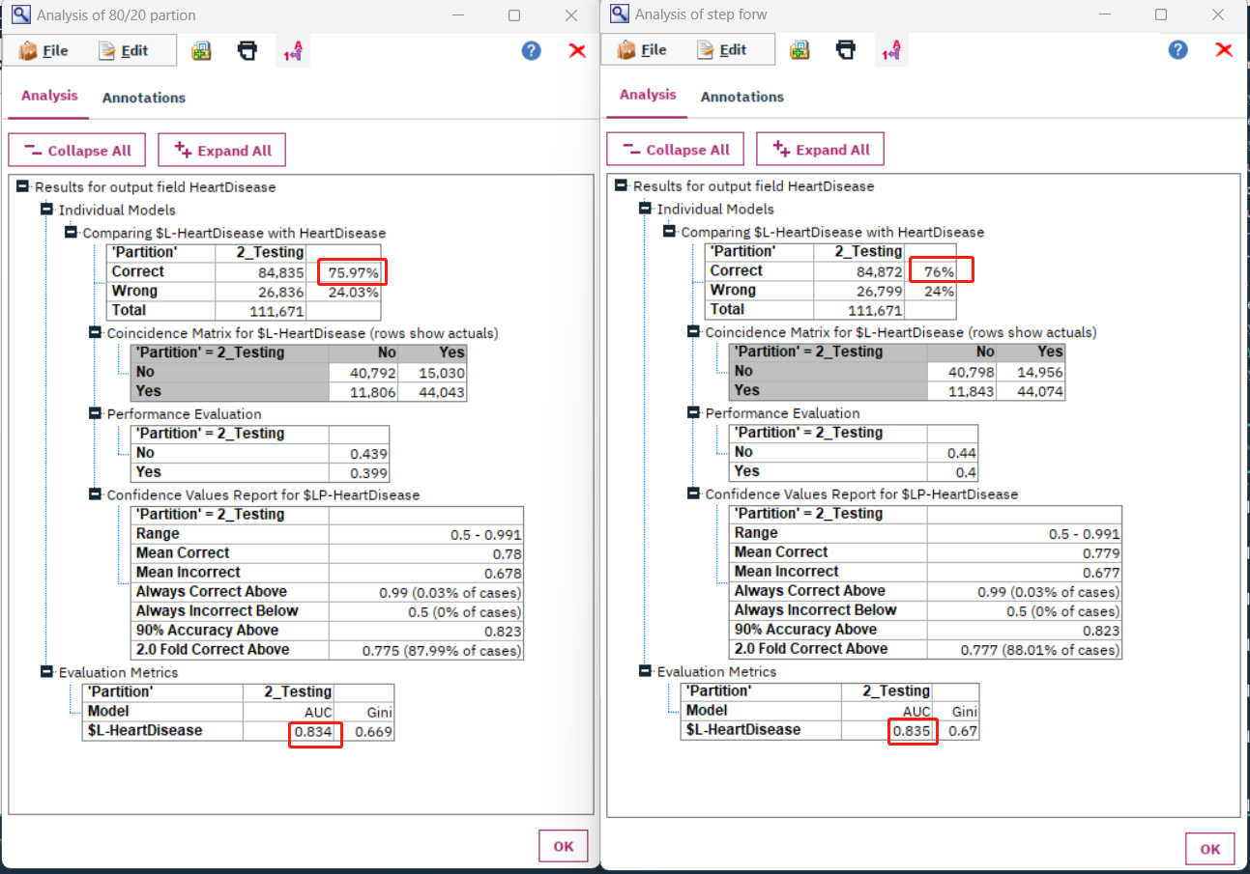

*Figure 100: Comparison of 2 models in analysis node*

Reference:

1. Connie W. Tsao, Aaron W. Aday, Zaid I. Almarzooq, Alvaro Alonso, Andrea Z. Beaton, Marcio S. Bittencourt, Amelia K. Boehme, Alfred E. Buxton, April P. Carson, Yvonne Commodore-Mensah, Mitchell S.V. Elkind, Kelly R. Evenson, Chete Eze-Nliam, Jane F. Ferguson, Giuliano Generoso, Jennifer E. Ho, Rizwan Kalani, Sadiya S. Khan, Brett M. Kissela, Kristen L. Knutson, ... Seth S. Martin. (2022). Heart Disease and Stroke Statistics—2022 Update: A Report From the American Heart Association. *American Heart Association.* *145:e153–e639.* [https://www.ahajournals.org/doi/10.1161/CIR.0000000000001052?utm_campaign=sciencenews21-22&utm_source=science-news&utm_medium=phd-link&utm_content=phd-01-26-22#](https://www.ahajournals.org/doi/10.1161/CIR.0000000000001052?utm_campaign=sciencenews21-22&utm_source=science-news&utm_medium=phd-link&utm_content=phd-01-26-22)
2. Usama Fayyad, Gregory Piatetsky-Shapiro, & Padhraic Smyth. (1996). *Knowledge Discovery and Data Mining: Towards a Unifying Framework.* AAAI Press, <https://aaai.org/papers/014-knowledge-discovery-and-data-mining-towards-a-unifying-framework/>

I acknowledge that the submitted work is my own original work in accordance with the University of Auckland guidelines and policies on academic integrity and copyright. (See: https://www.auckland.ac.nz/en/students/forms-policies-and-guidelines/student-policies-and-guidelines/academic-integrity-copyright.html).

I also acknowledge that I have appropriate permission to use the data that I have utilised in this project. (For example, if the data belongs to an organisation and the data has not been published in the public domain, then the data must be approved by the rights holder.) This includes permission to upload the data file to Canvas. The University of Auckland bears no responsibility for the student's misuse of data.